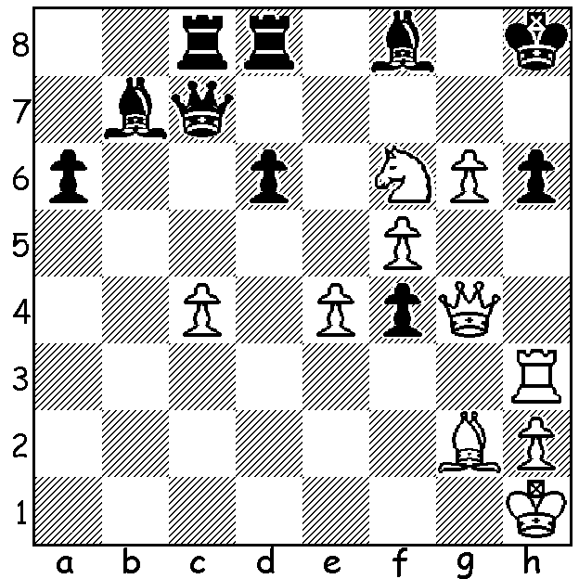
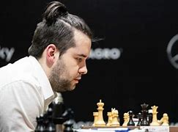

Ian Nepomniachtchi NEPO
vs Maxim Matlakov 2000
White to play mates in 3 or 4:

WHO WILL BE NEXT WORLD CHAMPION? (2)
There will be a new world champion this year after Magnus Carlsen decided to relinquish the title with either Ian Nepomniachtchi (Russia) or Ding Liren (China), winner and runner-up in the 2022 Candidates, taking the crown following their coming 14-game match in Kazakhstan, April 7 to 1 May. Born in 1990 Ian Alexandrovich Nepomniachtchi learnt chess at the age of four and became a GM in 2007. Among his many successes are: winner Russian Superfinal 2010 & 2020, European champion 2010, winner of 2016 Tal Memorial, winner of 2008 & 2015 Aeroflot Open, twice silver medalist at World Rapid, silver at World Blitz and silver at World Fischer Random. He won the 2021 Candidates to gain the right to challenge Carlsen for the world title but lost 3.5-7.5. His first place in the 2022 Candidates has given him a second tilt at the title. He will play under the FIDE flag. He was previously one of 43 leading Russian players who, in an open letter, condemned the Russian invasion, expressing solidarity with the Ukrainian people.

GUFELD CUP (WA Grand Prix) Sunday 9th and Monday 10th April at N Woodvale Primary: see cawa.org.au

SOLUTION: 1.g7+! (clearance sacrifice); if 1...Bxg7 2.Qg6 Bxf6 3.Rxh6+ Qh7 4.Q/Rxh7# or 2...Bf8 3.Qg8#; if 1...Qxg7 2.Rxh6+! Qxh6 3.Qg8#.

