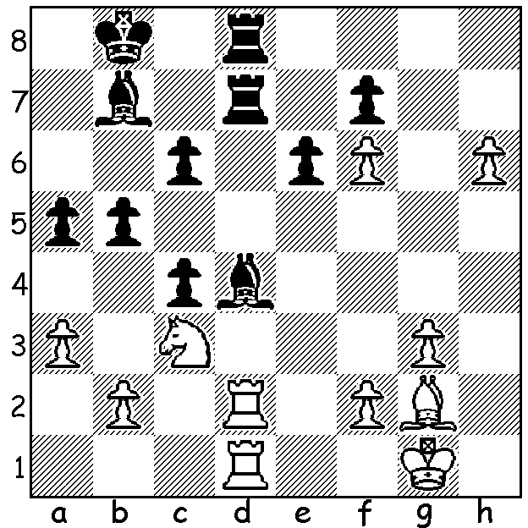
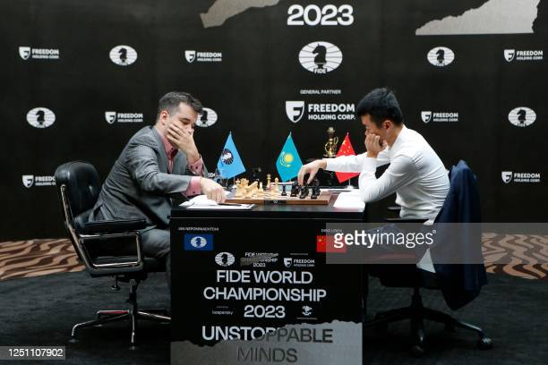
Nepo (L) vs Ding
Ding Liren vs (World Championship)
Anton Filippov 2010
White to play and win:

THE WORLD CHAMPIONSHIP HAS BEGUN
The World Championship between Ian Nepomniachtchi (Russia) and Ding Liren (China) began this week in Kazakhstan. The 14 game match is being played with a game a day starting at 3pm local time with breaks every third day. The time limits are 40 moves in two hours, then 20 moves in the third hour before fifteen minutes plus 30 sec per move to the end. Should the score be even after 14 games four Rapidplay games will be played (25min + 10sec) and if still needed two Blitz games (5min + 3sec). Finally if still level an Armegeddon games will decide (White receives one minute more than Black but must win). No draws by agreement are allowed before move 40. The prize fund is 2 million euro (1.2 million to winner, 0.8 million to loser). The first two games saw a confident Nepo against a slow Ding who struggled to hold the first game and succumbed in under 30 moves in Game 2 as Nepo unleashed a winning sacrifice with the Black pieces.

The DOEBERL CUP played over Easter in Canberra with 68 contestants in the Premier was won by Armenian GM Hrant Melkumyan with 8/9. Second was Australian champion WA GM Temur Kuybokarov, unbeaten on 7.5. Other WA players: Teh Rui Gen 5, Rebo Fu 4.5, Keegan O'Mahoney 3.5.

SOLUTION: 1.Rxd4! Rxd4 2,Rxd4 Rxd4 3.Nd5! (interruption sacrifice); if 3...c/exd5 4.h7 / 5.h8Q & if 3...Rxd5 4.Bxd5 / 5.h7 / 6.h8Q.

