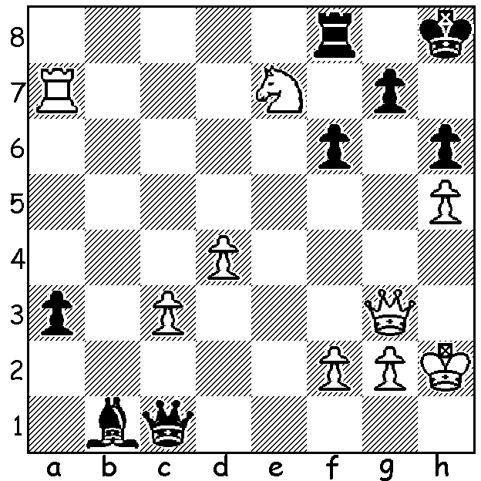
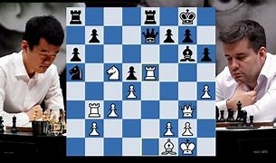
Ding (L) vs Nepo, Game 6
Ding Liren vs Ian Nepomniachtchi
Game 6, 2023: White has two brilliant
ways to mate: (Clues hidden in report):

NEPO LEADS AT HALFWAY STAGE
The World Championship between Ian Nepomniachtchi and Ding Liren is proving a fascinating struggle. At the halfway stage Nepo leads 4-3. Already five of the seven games have been been decisive (compare with the Magnus Carlsen matches against Sergey Karjakin in 2014 and Fabiano Caruana in 2018 in which Carlsen won one games and lost one of 24 games played, only retainimg his title in play-offs in rapid games). Clues: both back row mates with initial rook or pawn move.After his brilliant finish to game 6, Ding collapsed in Game 7. In a promising position but short of time he went astray and seemed frozen at the board at the end. He has been in regular time trouble throughout the match and it may prove his undoing, If you haven't already, try following the games online, perhaps after three hours play (start 3pm Kazakhstan is 5pm Perth).
I shall not be reporting on the Nepo-Ding match next week but shall be be starting a series of articles on the World Championship tournament and matches involving Mikhail Botvinnik between 1948 and 1963.

SOLUTION: a) 1.Rb7! a2 2.Rb8 a1=Q 3.Rxf8+ Kh7 4.Rh8+! Kxh8 5.Qb8+ Kh7 6.Qg8#:
b) 1.d5! (as played by Ding) 1...a2 2.Qc7! (threat 3.Ng6+ / 4.Qxg7#) 2...Kh7 3.Ng6 Rg8 4.Qf7! resigns (4... Qg5 5.Qxg8+! Kxg8 6.Ra8+ Kf7 7.Rf8#) - brilliant! Fortunately Ding had loads of time to calculate this move after having just passed the 40 moves in two hours time control.

