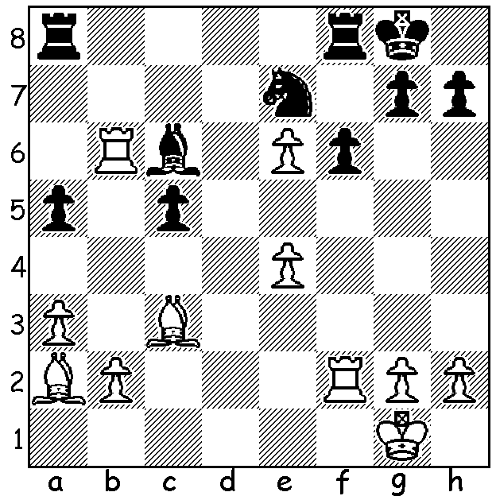
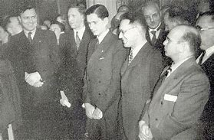
(L to R) Euwe, Smyslov, Keres, Botvinnik, Reshevsky
Mikhail Botvinnik vs Max Euwe
(World Championship 1948)
White to play and win.

DEATH OF WORLD CHAMPION
FIDE (The International Chess Federation), set up in 1924 as a kind of players' union, had been trying for a number of years to regulate world championahip matches. Following the death of world champion Alexander Alekhine in 1946, FIDE proposed a tournament comprising the top six players in the world with the winner to be declared world champion. The players, Mikhail Botvinnik, Vasily Smyslov, Paul Keres all (USSR), ex-world champion Max Euwe (Netherlands), Samuel Reshevsky and Reuben Fine (both USA), would each play four games against each of their opponents. When Fine declined to play it was decided not to invite another player but to have contestants play five games against each other The first half of the tournament was played at The Hague starting in March 1948 before being completed in Moscow. The Soviets brought a large contingent of 21, which included the three contestants' respective seconds and a doctor and, while Euwe had a second with him, Reshevsky travelled to the tournament alone, only getting a second upon arrival. The final result left Botvinnik, who was the favourite to win, clear first and world champion with 14/20 followed by Smyslov 11, Keres and Reshevsky 10.5, Euwe 4.

SOLUTION: 1.Rxc6! Nxc6 2.e7+ Rf7 3.Bd5! resigns. So many combinative themes in three moves, deflection, discovered check, pin, overworked piece and promotion.

