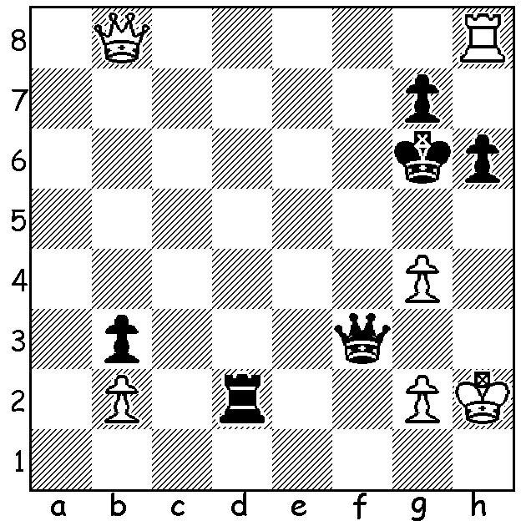
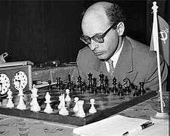
David Bronstein vs David Bronstein
Viktor Korchnoi 1962
White to play and win (3 moves):

BOTVINNIK'S FIRST CHALLENGER
Russian Mikhail Botvinnik, who won the first ever world championship tournament in 1948, was obliged to defend the title in 1951. His opponent was Ukranian born David Bronstein. Bronstein, born in 1924 into a poor family, learnt chess aged six from his grandfather and aged 16 came second in the Kiev championship. He was third in the 1945 USSR Championshipand was chosen in the USSR team vs USA, winning both games. He won the Soviet Chess Championship (jointly with Alexander Kotov) in 1948 and again in 1949 (jointly with Vassily Smyslov). He became a Grandmaster in 1950. He qualified for the 1950 Candidates (after winning the twenty-player Interzonal held in Sweden). He tied for first with Isaac Boleslavsky before winning a play-off 7-6 to earn the right to play champion Mickhail Botvinnik for the world title (more on that next week). He represented the USSR in four Olympiads between 1952 and 1958, losing only once in 49 games. He won a number of high level tournaments and was a very successful and respected writer with six publications. He was perhaps the first to propose the use of increments on the clock to avoid adjournments. In 1976 he refused to sign a document denouncing the defection of Viktor Korchnoi, paying a personal price, being stripped of his state stipend and being banned from top level tournaments. He died in 2006.

SOLUTION: 1. Rxh6+!! If 1...Kxh6 2.Qh8+ Kg6 3.Qh5+ Kf6 4.g5+ winning the queen; if 1...gxh6 2.Qg8+ Kf6 Qf8+ winning the queen; if 1...Kf7 2.Qc7+ Kg8 3.Qc8+ Kf7 4.Qe6+ Kf8 5.Rh8#. if 1...Kg5 2.Qe5+! Kxg4 (2...Kxh6 3.Qh5#) 3.Rg6+ Kh4 4.Qh5#.

