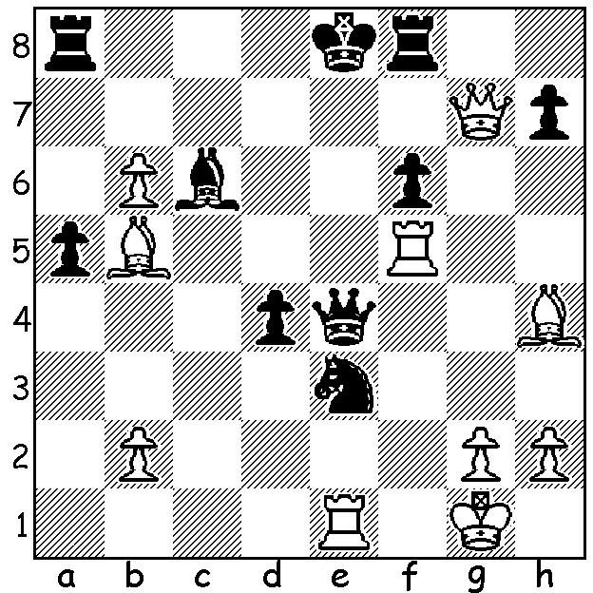

David Bronstein vs
Grigory Levenfish 1946
White to play and win
(3 moves):

BOTVINNIK vs BRONSTEIN
The first World Championship match controlled by FIDE between champion Russian Mikhail Botvinnik aged 39, and Ukranian born David Bronstein, aged 27, was a close and exciting affair with the Tschaikovsky Concert Hall in Moscow packed for each game.This 1951 match was to be decided over twenty-four games with the champion to retain the title in the event of a 12-12 result. Five hours were allotted for each playing session with adjournments the following day if required. Botvinnik had played no chess since winning the title in 1948 but would have prepared thoroughly studying Bronstein's games and especially his opening play. Interestingly Bronstein never used his favourite Kings Indian Defence in the match, instead tending to mimic Botvinnik's Dutch Stonewall. The match was a contrast in style with Botvinnik, who had formulated a scientific approach to the game, opposed to the romantic and creative style of Bronstein. The match was close throughout with Bronstein a point ahead after Rd 22. However Botvinnik won a long endgame in Rd 23 a pawn down but with two bishops vs two knights and retained the title with a final draw leaving the match tied at 12 all, five wins each, with Botvinnik's superior endgame skill being decisive in retaining the title.

SOLUTION: 1. Re5+!! If 1...Qxe5 2.Bxc6+ Kd8 3.Qd7# or 1...fxe5 Qe7# (combinative themes - interruption, deflection, overworked piece).

