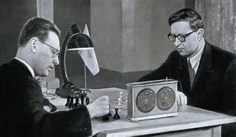
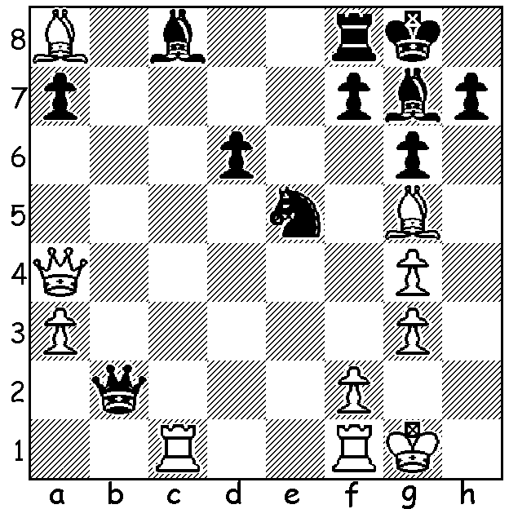
Botvinnik (L) ves Smyslov 1954
Mikhail Botvinnik vs
Vassily Smyslov
World Ch.1954, Game 14
Black, the exchange down,
seems in trouble but a surprise
move turns the tables:

BOTVINNIK'S SECOND CHALLENGER - SMYSLOV (1)
Mikhail Botvinnik's second challenger was a long-term younger rival, Vassily Smyslov (1921 - 2010). Throughout their careers they played 98 times with Botvinnik slightly ahead with +26 =50 - 22. Smyslov had been runner-up when Botvinnik won the five-player world championship tournament in 1948 and won the gruelling 15 player 1953 Zurich Candidates tournament with 18/28, two points ahead of Botvinnik's first challenger David Bronstein. The match in 1954, with similar conditions to the Botvinnik-Bronstein match could hardly have started worse for the challenger with Smyslov falling three points behind after four games. Smyslov gradually whittled away the deficit and levelled the score with wins in Games 20 & 23. However he could make no progress in the final game with the drawn match enabling Botvinnik to retain the title for the second time 12-12. Only ten of the games drawn. Smyslov generally played 1.e4 with Botvinnik employing the French Winawer on seven occasions with three losses and one win but scoring 2/ 2 against Smyslov's Closed Sicilian (1.e4 c5 2.Nc3). Botvinnik exclusively played 1.d4 with Smyslov's most successful defence the King's Indian Defence scoring +2 =2 -1.

SOLUTION: 1. ..Bb7!! (inviting the skewer) 2.Rb1 Nf6+! 3.Kh1 Bxa8 4.Rxb2.Nxg5+ 5.Kh2 Bxb2 and the three minor pieces opposed to the queen were able to take advantage of White's weakened king side.

