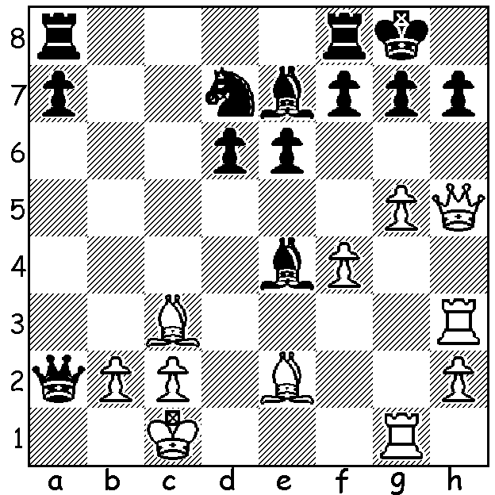
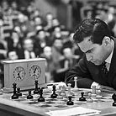
Mikhail Tal vs Mikhail Tal
Alexander Koblents, 1965:
White, a piece down, to play
and mate (4 moves):

BOTVINNIK FACES ATTACKING GENIUS
After recovering the world title from fellow Russian Vassily Smyslov, Mikhail Botvinnik at 58 faced a challenge from a much younger opponent, Mikhail Tal from Latvia aged 23. Tal, called The Magician from Riga, possessed a reputation as a creative genius, ever ready to sacrifice for an attack or the initiative. He first won the Latvian Championship in 1953 aged 16. In 1956 he played in his first Soviet Championship, coming 5th, and in 1957 he became at 20 the youngest ever player to win the championship, a performance which led to his being awarded the Grandmaster title. In 1958 he won the Candidates tournament with 20/28 ahead of, among others, Paul Keres, Tigran Petrosian, Smyslov and a 16 year old Bobby Fischer. The 1960 world championship match aginst Botvinnik ended in a convincing win to Tal 12.5-8.5 (+6 =13 -2) but in the return match Botvinnik, as he had done against Smyslov, regained the title (13-8, +10 =6 -5). Tal suffered from bad health for much of his life, was plagued by kidney problems (one was removed in 1969), was a chain smoker and drank heavily, but despite this he continued to win events. Some of his major successes included Soviet champion six times, eight Olympiads for USSR winning 65% and losing only two. In the 1970s he played 86 games without losing and later bettered this with 95 games without loss (a record only beaten by Ding Liren and then Magnus Carlsen). In 1970 he was runner-up to Fischer in the World Blitz Championship and bettered this in 1988 winning ahead of Garry Kasparov, one month before his death at 55.

SOLUTION: 1.g6!! Bxg6 2.Qxh7+!! Bxh7 3.Rxg7+ Kh8 4.Rhxh7#. So many brilliant Tal wins came after earlier positional sacrifices (check out 30,000 chess puzzles by W T Harvey).

