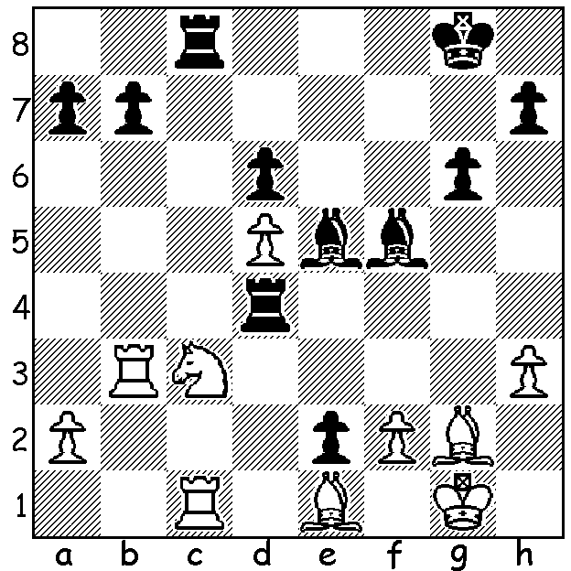
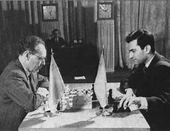
Mikhail Botvinnik vs Botvinnik (L) vs Tal 1960
Mikhail Tal Match 1960:
Black to play and win
(5 moves):

BOTVINNIK vs TAL (I)
The venue in Moscow for the 1960 Botvinnik vs Tal World Championship matches, the Pushkin Theatre, was usually filled with spectators who were enthralled by the contrasts between the players, the age difference with the Russian Botvinnik 48 and the Latvian Tal 23, their style, with the steady methodical play of the champion since 1948 opposed to the impulsive creative genius of the challenger who would, between moves, pace around the stage like a tiger. Many who could not get admission watched the games from large chess boards set up outside. The very first game saw Tal victorious against Botvinnik's favourite French Winawer causing the champion to switch to the more positional Caro-Kann where he scored one win and two losses in nine games. Things looked bleak for the champion when in Game 6 Tal (Black) unleashed an unexpected early knight sacrifice in a Kings Indian Defence (see position) to gain a two point lead. Botvinnik was unable to make any headway, only winning once in ten games as White, and eventually losing the match 8.5 - 12.5, with Tal becoming the youngest ever world champion.

SOLUTION: 1...Rxc3! (removing a defender of d1) 2.Rbxc3 Rd1 3.Rc4 Bb2. The position came from Game 6 of the first match. Tal (Black) had made an audacious knight sacrifice on f4 and the crowd was abuzz. Frequent attempts were made to quieten them without success so the game with this position was moved from the stage into an adjoining room. It's thought that this distracted Tal so much that he failed to find this move, marring the brilliance of his play and needing nearly 20 more moves to win after playing 1...Bf4.

