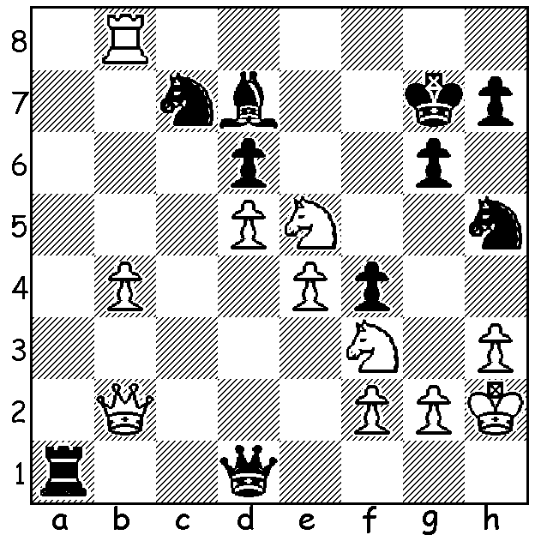
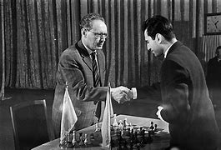
Botvinnik (L) vs Tal, 1961
Mikhail Tal vs
Johann Hjartarson 1987
A piece down and faced with mate,
can White win (4 moves)?

BOTVINNIK vs TAL (II)
After losing the world title to Mikhail Tal in 1960, Mikhail Botvinnik exercised his right to a return match the following year. Most would have given him little chance after Tal's convincing win by 12.5-8.5. However a number of factors contributed to prove the return match was far from a certainty for Tal. Firstly the determination of Botvinnik who prepared thoroughly, seeking to find the kind of positions (eg solid pawn structures requiring patient manoeuvering) which lessened the possibilities of Tal using his attacking skills. He also sought to improve his fitness to avoid tiring in the fifth hour of games (he took to drinking coffee during a game to provide an energy boost). Tal, on the other hand had appeared over-confident and failed to prepare. Perhaps the deciding factor though was Tal's health. A Latvian doctor had requested the postponement of the match because of Tal's chronic kidney problems but Botvinnik objected and proposed Tal be examined by a doctor in Moscow. Tal then agreed to play as scheduled but suffered a heavy defeat. As White Botvinnik savaged Tal, scoring 8.5/11 (+8 =1 -2), mainly against the Nimzo-Indian and Kings Indian, while holding his own with the Caro-Kann (+2 =5 -2) and winning the match 13-8, giving him the title for the third time.

SOLUTION: 1.Ng4+ Kf7 2.Nh6+ Ke7 3.Ng8+ Kf7 4.Ng5# - a KNightmare for Black!

