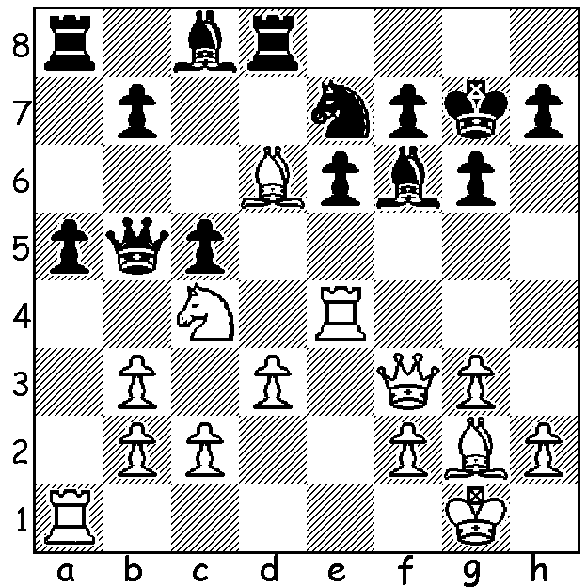
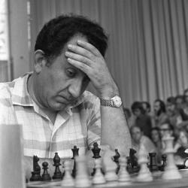

Tigran Petrosian vs Tigran Petrosian
Ludek Pachman 1961
White wins brilliantly -
move 3 is difficuly to
see (7 moves):

TIGRAN PETROSIAN
Botvinnik's final challenger for the world title was the Armenian Tigran Petrosian (1929-1984). Petrosian learnt to play chess at eight. After being orphaned during WWII he swept streets to earn a meagre living. Despite his poverty he bought Chess Praxis by Nimzovitsch, a writer who would have a profound influence on his chess style. At 12 he entered a chess academy where his tutor was also a supporter of the theories of Nimzovitsch as well as those of Capablanca. The young Tigran also studied Nimzovitsch's My System. He moved to Moscow in 1949 where his career advanced rapidly. He came second in the 1951 Soviet Championship where he played Botvinnik for the first time and defended well to secure a draw after 11 hours. He went on to win the Soviet Championship four times. He was a Candidate for the World Championships on eight occasions, winning in 1962, thus gaining the right to challenge Botvinnik for the world title which he won 12.5- 9.5 (+5 =15 -2). He successfully defended the title in 1966 against Boris Spassky 12.5-11.5 (+4 =17 -3) but lost the title in 1969, again playing Spassky, 10.5-12.5 (+4 =12 -6).

SOLUTION: 1.Qxf6+!! Kxf6 2.Be5+ Kg5 3.Bg7! resigns: there is no defence - 3...Rxd3 4.cxd3 and then - a) 4...e5 5.h4+ Kh5 6.Bf3+ Bg4 7.Bxg4#: b) 4...Nf5 5.h4+ Nxh4 6.gxh4+ Kh5 7.Bf3#: c) 4...Kf5 5.Rf4+ Kg5 6.h4+ Kh5 7.Bf3#.

