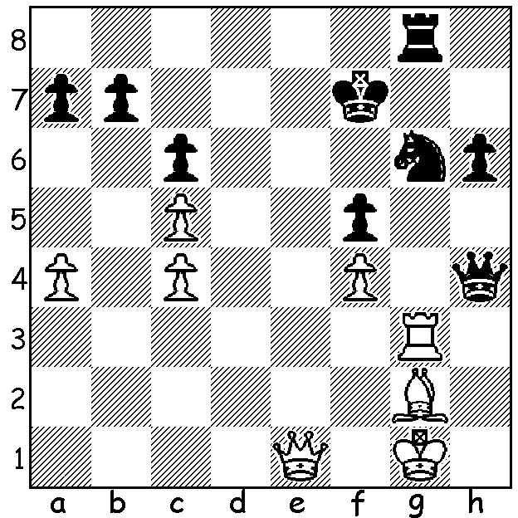
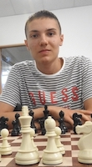
Kasper Piorun vs Temur Kuybokarov
(Sharjah Masters 2023)
Black to play and win.

LOCAL PLAYERS' SUCCESSES
WA's players have recently been active on the International chess scene with considerable success. Firstly Australian champion Temur Kuybokarov has won the Oceania Zonal played in Melbourne with 254 players. He was in a group of six players finishing with a score of 7.5/9 and then defeated Gary Lane 2-0 in a playoff, thus qualifying as the Oceania representative for the World Cup. Also on 7.5 was WA's Patrick Gong who has since been awarded the title of IM (International Master) - congratualions. There was a strong WA contingent at the event, all of whom achieved a 50% score or above - Rebo Fu 6.5, Adam Kelly 6, Neville Shah, Oscar Goh both 5.5 and on 4.5 Samanda and Yonai DeVas, Shannon Koh, Iker Hernandez-Mendez.
The Womens Zonal (43 players) was won by Melbournian Julia Ryjanova with 8/9. WA's Kathryn Hardegen, who has previously represented Oceania in the Womens World Cup, scored 5.5. Other WA players - Celine Ong 4.5 and Senudi De Vas 3 9 (both juniors)..
Temur has recently competed in a 78 player all Grandmaster tournament, the Sharjah Masters, scoring 5/9 (=19th-34th). Winner was 19 year old Indian Arjun Erigaisi with 6.5/9.

THE SW OPEN will be played Sat 29 & Sun 30 July in Margaret River. Check details at cawa.org.au and get your entry in soon.

SOLUTION 1...Ne4! (clearance sacrifice); if 2.Rxg8 Qxe1+ or 2.fxe5 f4 wins the rook. White played 2,Qxe5 but was lost after 2...Rxg3.

