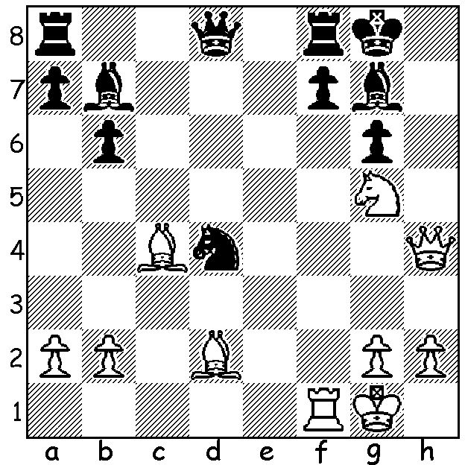
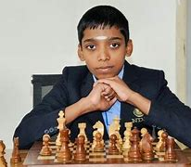
Gawain Jones vs Rameshabu Pragganandhaa
Chessable Masters 2022 (Rapid)
Black to play and win.

NEW TEAM EVENT
In collaboration with FIDE, Tech Mahindra set up a team event in India which attracted many of the world's top players including Magnus Carlsen.The stated aim of the event, which was televised, was to bring together the best players and also make the sport more spectator friendly. Ten teams, comprising six players including two women players and one leading Under 21, played a double round robin with one team playing White on all boards and then all Black in the return match. Time control was 15min + 10 sec. Winning a match earned three points and a drawn match one point with the top two teams qualifying for the final. The two leg final was played between Triveni Continental Kings led bt Levon Aronian and upGrad Mumba Masters led by Maxime Vachier-Lagrave. After each team won a match each they also each won a Blitz match (3min + 2sec). This led to a single Blitz game decider between one player from each team, the board chosen by lot. A draw resulted in the first three games before Jonas Bierre (Triveni) defeated Javokhi Sindarov. Sindarov had defeated Bierre in all four games previously and had declined a draw offer before missing a mate in one threat. The best performance was by 17 year old Rameshbabu Pragganandhaa who scored 8/9.

THE SW OPEN will be played Sat 29 & Sun 30 July in Margaret River. Check details at cawa.org.au and get your entry in soon.

SOLUTION: faced with mate Black finds 1...Nf3+! (clearance sacrifice) forking K & Q and after the capture of the knight Black exchanges queens with 2...Qd4+ to secure the win.

