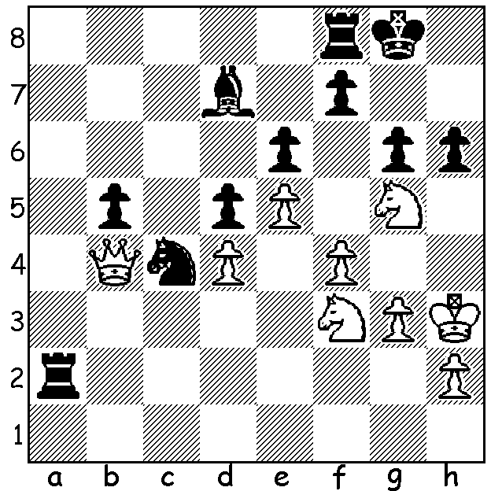
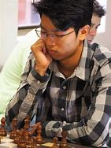

Patrick Gong v Christopher Wallis
Australian Young Masters 2017
White to play and win.

WEST AUSTRALIAN CHAMPIONSHIP
The recently completed West Australian Championship with 34 competitors finished with no clear winner. A play-off will be held between IM Patrick Gong and Rui Gen Teh, both of whom scored 6/7. Equal third were former champions Tim Hare (who gained the Seniors prize) and Jamie Laubbacher with 5/7. With several players tied on 4.5, there will also be a play-off for the Reserves (Undwe 2000) tirle. Kathryn Hardegen with 4.5 retained the titleof Womens Champion while Celine Ong with 3.5 was the leading girl player.
Proof that WA chess is on the move, with GM Temur Kuybokarov Australian Champion and Patrick Gong gaining his IM (International Master) title, is the selection of three West Australians, Rebo Fu, Rui Gen Teh and Iker Hernandez-Mendez for the Australian FIDE World Under 16 Team Championships (2 teams, 4 players each team). Iker was also winner of the Metro Club championship with 9/9 earlier this year.

THE SW OPEN will be played Sat 29 & Sun 30 July in Margaret River. Check details at cawa.org.au and get your entry in soon.

SOLUTION: Already with a material disadvantage and a knight with seemingly no escape, White wins with 1.Nh7! Rd8 (1...Kxh7 2.Qxf8) 2.Qe7 Raa8 3.Nf6+ Kg7 4.Nxd7 & wins.

