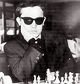
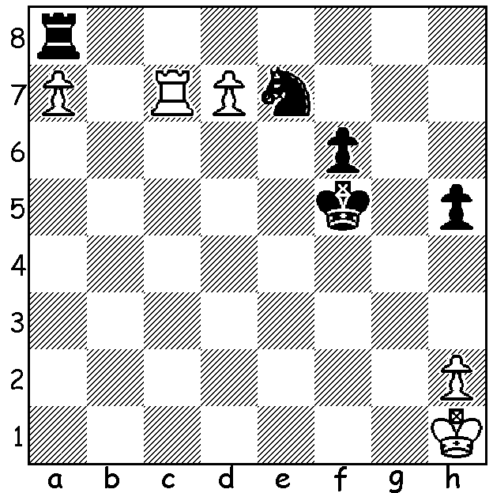

Dragoljub Baretic vs Dragoljub Baretic
Bernard Cafferty
(Hastings 1961-62)
White to play and win.

OVERCOMING DISABILITIES
I recently read an amazing story of a severely handicapped plyer who recently fulfilled all requirements for the IM (International Master) title. Polish player Lucasz Nowak was diagnosed with a severe form of spinal muscular atrophy soon after birth in 1997 which resulted in an almost total inability to move any part of his body. He needs an assistant at tournaments who will, after verbal instruction, make the move, press the clock and keep the score of the game. Nowak gained his first IM norm in 2016 with his highest rating being 2406.
Another serious handicap is blindness which has not prevented players from achieving considerable success. I played at the Hastings International Chess Festival in 1961-62 where I scored 6.5/9 (=2nd) in the Open A. However my main interest was watching the legendary Mikhail Botvinnik (world champion for most of the period 1948–1963). I was also attracted to the play of Dragoljub Baretic (1936-2018) who won the Premier Reserves A. Baretic lost his sight in partisan wars in Yugoslavia but this did not dampen his enthusiasm for the game. Blind players usually use a braille plug-in set (raised black squares and points on all Black pieces) to analyse and move before the move is then transferred to the main board but Baretic was able to make moves unaided like sighted players.
.
SOLUTION: 1.Rc8! If 1…Rxc8 2.dxc8=Q Nxc8 3.a8=Q; if 1…Nxc8 2.d8=Q. Bernard Cafferty, a leading English playerof the 1950s and 60swas four times British Lightning champion, British Correspondence champion 1959-60 and runner-up in the 1964 Britich Championship.

