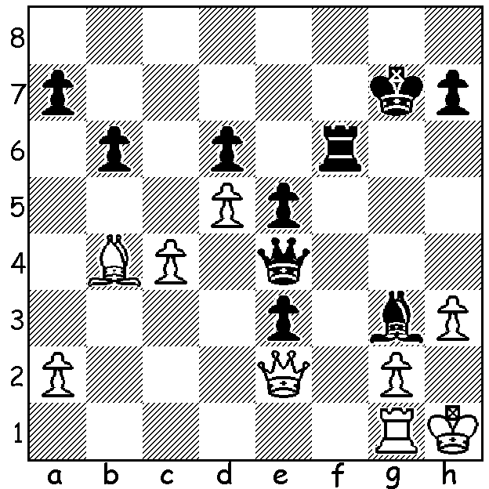

[DIAGRAM HERE]
Alexsandra Goyachkina
vs Ju Wenjun 2012
Black to play and mate in 6.

WOMENS WORLD CHAMPIONSHIP
The recently completed 12 game Womens World Championship between champion Ju Wenjun and challenger Lei Tingjie was played in two Chinese cities, firstly in Chonqing, the birthplace of Lei, and then in Changhai where Ju was born. Ju, 32, won the title by defeating then world champion Tan Zhongyi in 2018 and then successfully defended the title later in 2018 in a 64 player knock out. In 2020 she defeated Aleksandra Goryachkina in a rapidplay tiebreaker, again to retain the title. Lei, 26, won the eight player knock out Candidates Tournament earlier this year defeating former champion Tan Zhongyi 3.5-1.5. In their match Lei won Game 4 before Ju equalised after winning game 8. With scores level and a rapidplay tiebreaker looming, Ju won the final game to keep the title (+2 =9 -1).

The WA BLITZ CHAMPIONSHIP was played at the State Library on 16 July with 47 entrants. Winner was IM Patrick Gong on 9.5/11 closely followed by Rebo Fu on 9. Equal third were a former WA champion Michael Wilkins in a return to chess after many years and Marc Vliestra in a rare appearance. Other main prize winners: Senior Champion Tim Hare 7.5, Womens Champion Kathryn Hardegen 7.5. Top rating prizes: Under 1950 Craig Kinsman (7), Under 1450 Eric Deng & Yonal De Vas 6.5, Under 1100 Carter Kerr 5.5, Under 800 Leo Gong 5.

SOLUTION: Things to note: White’s g pawn is pinned and White’s king has no escape squares on the second rank. 1…Rh6 2.R moves Rxh3+ 3.Kg1 Rh1+! 4.Kxh1 Qh4+ Kg1 5.Qh2+ Kf1 6.Qh1#.

