CHESS August 5 2023 David Ellis 0439798607 / ellisd19@bigpond.com

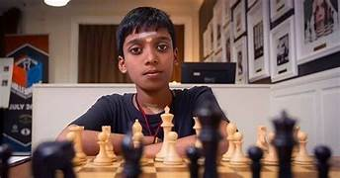
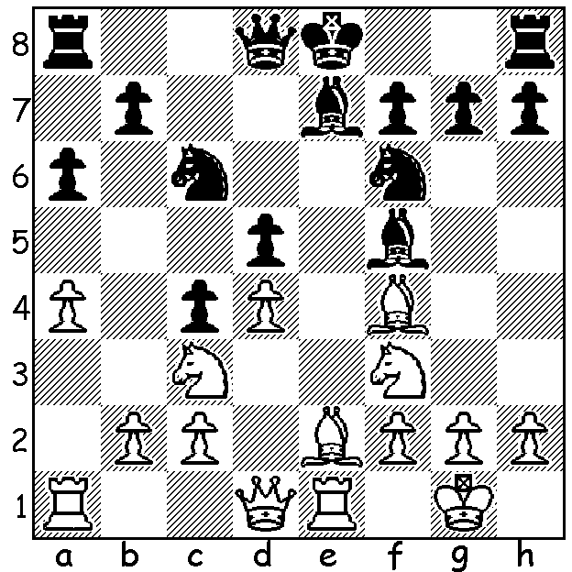

Rameshbabu Praggnanandhaa
vs Steven Pastar 2014.
White to play.
What is the best move?

SEVEN YEAR OLD’S SENSATIONAL SCORE
The South West Open (WA Grand Prix event) was played last weekend in Margaret River with over 40 players, both young and old, from both Perth and the South West, competing in a six round Swiss tournament. Winner was Marc Vliestra with 6/6, followed by seven year old Carter
Kerr who, after losing his first round game to former WA champion Tim Hare, won his final five games including victory in his final game against another leading WA player Andrew Hardegen. Carter’s elder brother Lennon, also a promising player, scored 3/6. Other leading prize winners: Open – 3rd David Ellis 4.5/6: Under 1850 –1st Dominador Andador 4.5/6: Under 1550 – 1st= John Prince, Michael Molenaar and Kobe Wu 4/6: Under 1300 & unrated – Nathanael Mezger 3.5/6 (Although first in all rating groups Carter’s second overall place made him ineligible to gain rating prizes *). John Prince of Margaret River and Michael Molenaar of Bunbury became joint WA Country champions. One may wonder why some young children can play chess at such a high level. Children can pick up complex patterns and skills (seen in chess, music and languages) better at a young age and find it easier to memorise.

The next GP event is the Willetton Open on 19 & 20 August. See cawa.org.au for details and entry form.

CHESS WORLD CUP: The Chess World Cup in Baku, Azerbaijan, has begun. Australia has two players in the Open, WA’s Australian champion GM Temur Kuybokarov ** and a former World Under 12 champion GM Bobby Cheng, and two players in the Women’s, WGM Julia Ryjanova and WGM Jilin Zhang. Temur defended well to draw his first game, then won the second to advance to the second round

WA CHAMPIONSHIP PLAY-OFF: IM Patrick Gong defeated Rui Gen Teh 2-0 to win the WA Chess Championship. Patrick now holds all three major WA titles, Championship, Rapidplay and Blitz Championships, all titles he has now won on three occasions.

SOLUTION: 1.Bxc4!; the games continued 1…dxc4 2.d5 Nb4 (2…0-0 seems wiser) 3.d6! Bxc2 4.Qd2 Ng8 5.Nd5 Nd3 6.Nc7+ Kf8 7.dxe7+ Nxe7 8.Nxa8 winning. Prag was aged 9 at the time of this game. He became a GM at 12 and recently attained a rating of over 2700 while still only 17.

* As 1st Under 1850 prize was larger than Open 2nd, Carter received the rating prize.

