CHESS August 12, 2023 David Ellis 0439798607 / ellisd19@bigpond.com

Two puzzles with similar themes, both from Rd 2 of World Cup:
A) Black to play (Huschebeth Niclas vs David Navara):
B) White to play (Dimitri Kollars vs Ruslan Panamariov).

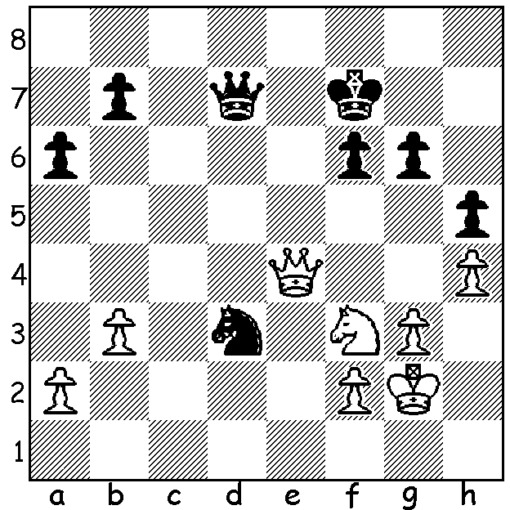
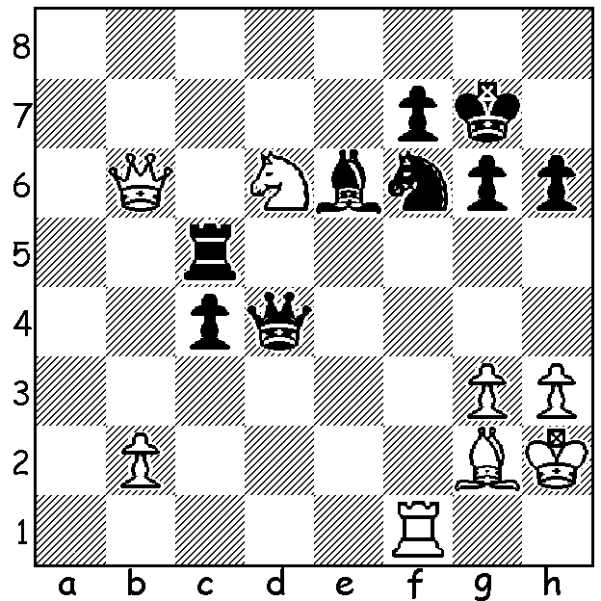
A. B.

CHESS WORLD CUP
WA’s Australian champion, GM Temur Kuybokarov advanced to the second round of the 2023 World Cup with a win and draw against Ukrainian Vitaliy Bernadsky. In round he faced three times Chinese champion Yu Yangyi (China). After losing game 1 Temur pressed hard in Game 2 but could not gain the win to take the match into a rapidplay tie break.
After losing Game 1 in the first round Australia’s other entrant GM Bobby Cheng won as Black against Azerbaijan’s Misratdin Iskandarov. However after drawing and then losing he was eliminated in the rapidplay.
The Open Finals, being played in Baku, Azerbaijan, the birthplace of Gary Kasparov, began
with 206 players, with the 50 top ranked players having a bye into Rd 2. To progress a player needs to defeat an opponent 2-0 or 1.5-0.5. If there is a draw 1-1 in their Classic games (90 min + 30 sec increments) further games are played, firstly two 25 min + 10 sec increment rapidplay games, then, if necessary, 10 min + 10 sec rapidplay games and then if still tied two 5 min + 3 sec blitz games.

2023 WILLETTON OPEN: Sat 19 & Sun 20 August at Leeming Primary. See cawa,org,au for details and entry.

SOLUTIONS: A)1...Qh3+!! (missed by Navara) 2.Kxh3 Nxf2+ / 3…Nxe4 and if 2.Kg1 Qh1+!
B) 1.Rxf6!! (1…Qxf6 2.Qxc5) 1…Kxf6 2.Qxc5! Qxc5 3.Ne4+ / 4.Nxc5.

