CHESS August 19, 2023 David Ellis 0439798607 / ellisd19@bigpond.com

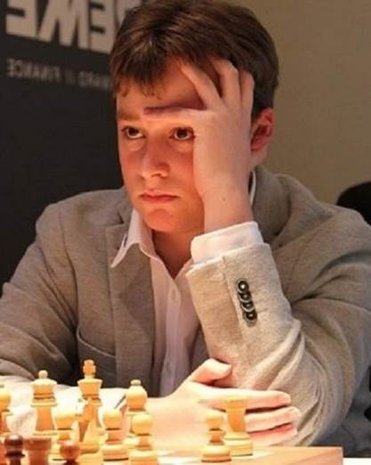

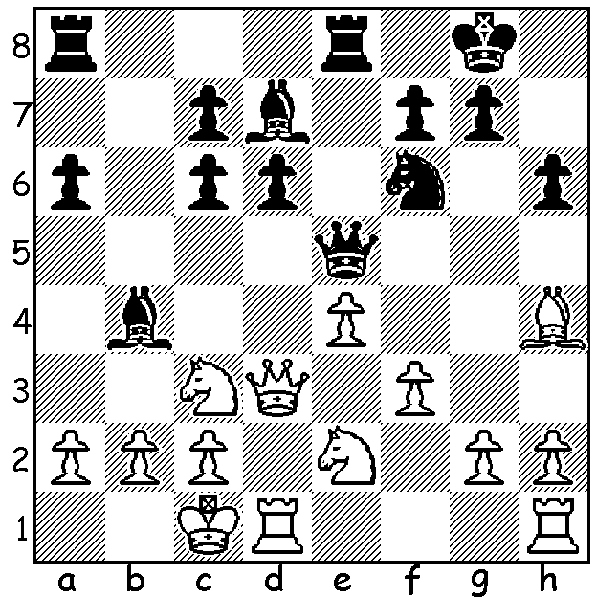
Magnus Carlsen vs Vincent Keymer
(2023 World Cup, Rd 4):
White now errs with 1.a3?
How could Black profit?

MAGNUS SURVIVES AFTER SECOND SLIP
Since its inception in 2000 the Chess World Cup has never been won by former world champion (2013-23) and still World Number 1, Magnus Carlsen. This year in Rd 4 he came close to elimination again, this time at the hands of German Vincent Keymer. After losing the first game after an uncharacteristic error, he again presented his 18 year old opponent with winning chances (see diagram). However Keymer missed the opportunity and was ground down in an ending. Magnus then won the two 25 minute rapidplay games to advance to Rd 5. After defeating Ukrainian veteran Vassily Ivanchuk his opponent in the quarter finals is 17 year old Dommaraju Gukesh who recently climbed to seventh in world rankings. Gukesh is joined by three more of a young Indian brigade seeking the title, 18 year old Rameshbabu Praggnanandhaa, 19 year old Arjun Erigaisi (paired against each other) and 20 year old Gujrathi Vidit who faces Azerbaijani Nijat Abasov. Vidit was the only winner to go into play-off games in Rd 5. After draws in the two classic games and two more draws in 25 minute rapidplay games, he defeated Russian Ian Nepomniatchtchi in both the two 10 minute rapidplay games. The remaining quarter final match is between two Americans, Leinier Dominguez and Fabiano Caruana, who had advanced after defeating the defending champion Jan Krzysztof Duda (Poland).

SOLUTIONS: 1...Bxc3 2.Qxc3 (2.Nxc3? Qf4+ wins the bishop) 2…Nxe4! 3.Qxe5 (3.fxe4 Qxe4 forking bishop and knight) 3…Rxe5 and if 4.fxe4 Rxe4 wins the bishop or knight to be two pawns up. A constant losing theme is unprotected pieces.

