CHESS August 26, 2023 David Ellis 0439798607 / ellisd19@bigpond.com

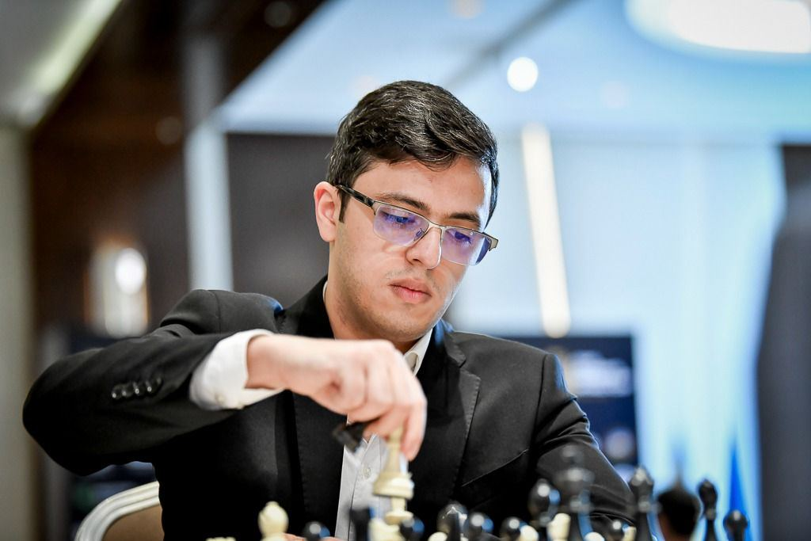
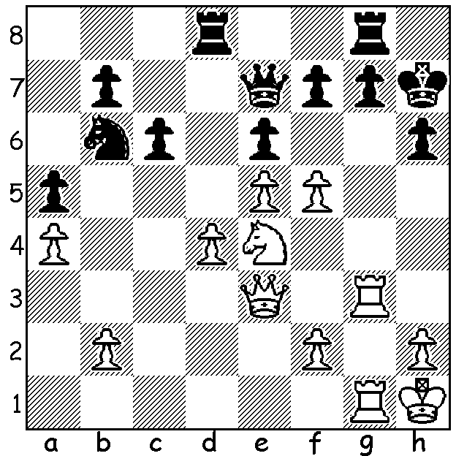

Nijat Abasov vs Fabiano Caruana Nijat Abasov
(2023 World Cup)
After White’s 1.f5! Black resigned.
Can you see why?

BATTLE OF GENERATIONS
Last week I reported on the quarter finals of the 2023 World Cup in Baku, Azerbaijan, with the world’s top player and ex-world champion Magnus Carlson defeating rising star 17 year old Indian Dommaraju Gukesh, Fabiano Caruana defeating fellow USA GM Leiner Dominquez and local Nijat Abasov, aged 18, defeating another Indian 19 year old Gujrathi Vidit. The last match to finish was the all-Indian clash between 18 year old Rameshbabu Praggnanandhaa and 19 year old Arjun Erigaisi which needed Classic, Rapidplay and Blitz before Pragg won the Tie-Breaker and the match 5-4. Notably almost all the games were decisive with Black more often on top.

The semi-final draw saw Pragg defeat Caruana 3.5. After Classic draws and Rapidplay draws Pragg won the third Rapidplay game and drew the fourth to emerge victor 3.5-2.5. Carlsen had an easier match, defeating the local hope Nijat Abasov 1.5-0.5. In the first game Carlsen was on top for most of the game before gifting Abasov a chance to turn the tables. However the opportunity was missed and Carlsen then won quickly.

The two Classic Pragg-Carlsen game lacked excitement with exchanges leading to a drawn endings. However local hero Abasov demolished Caruana in the play-off for third place with Caruana resigning before a likely mating queen sacrifice. (see diagram). However Caruana ground down his young opponent in the second game to equalise, leaving both matches to be decided in Rapid or Blitz.

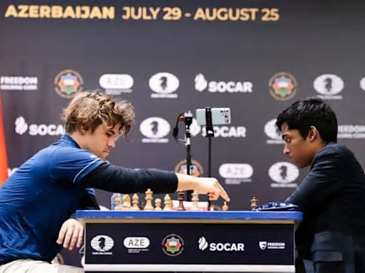
SOLUTIONS: a)1…exf 2.Nf6+!gxf6
(2..Kh8 3.Qxh6+! gxh6 4.Rxg8+ Rxg8
5.Rxg8#) 3.Qxh6+! Kxh6 Rh3#:
b) 1…Nd5 2.f6 ! gxf6 (2…Nxe3
3.Rxg7+ Rxg7+ 4.Rxg7+ Kh8
5.fxe7 Re8 6.Nf6+)
3.Qxh6+! Kxh6 4.Rh3#.

Carlsen vs Pragg

