CHESS September 9, 2023 David Ellis 0439798607 / ellisd19@bigpond.com

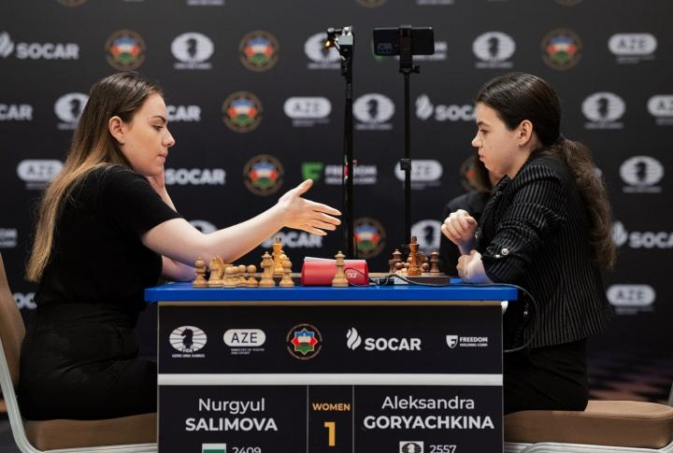
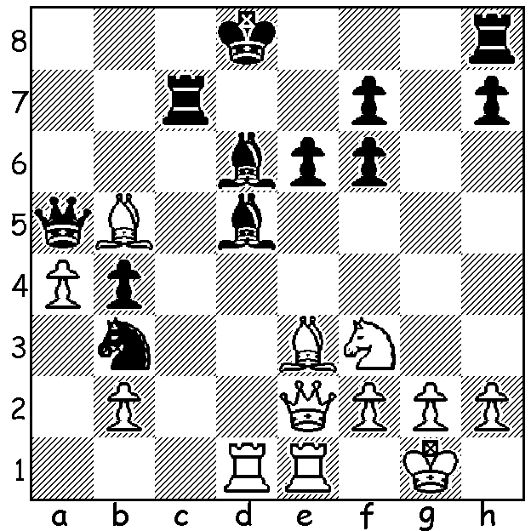

Nurgyul Salimova vs Anna Muzychuck Nurgyul Salimova vs Aleksandra Goryachkina
(2023 Womens World Cup). Final of Womens World Cup
White has a sacrificial mating attack.
Can you find it (4 moves)?

YOUNG STAR FALLS JUST SHORT
The Womens World Cup was played concurrently with the World Cup (Open) in Baku, Azerbaijan last month with a similar format, though with one less round with 103 players (Open 206) and 25 (rather than 50) seeded players automatically progressing to Round 2. Australia had two representatives and while Zhang Jilin was knocked out in Rd 1, Julia Ryjanova won in Rd 1 before losing in Rd 2. World champion Ju Wenjun was defeated in Rd 4 by Elisabeth Paehtz (Germany).
The semi-final pairings had Anna Muzychuk (Ukraine) opposed to Nurgyul Salimova (Bulgaria) and Tan Zhongyi (China) facing Aleksandra Goryachkina (Russian playing under FIDE flag). Aged just 20, Salimova, seeded 29th surprisingly defeated Anna Muzychuk (seeded 9th, former runner-up in Womens World Championship and former winner of Womens Rapidplay Championship & Womens Blitz Championship) 3.5-2.5 while Goryachkina (seeded 2^{nd,} runner-up to Ju Wenjun in 2020 Womens World Championship) defeated Tan (seeded 6th, Womens World Champion 2017) 1.5-0.5.
In the final Salimova pressed in the first three games but failed to score a win. In the fourth she was a pawn down for nearly all the game but missed a relatively simple pseudo-sacrifice to draw and lost the game after more than 100 moves and the championship 1.5-2.5. A disappointment for the young Bulgarian but her performance has qualified her for the next Candidates Tournament to find a challenger for the world champion. In the play-off for 3rd Muzychuk defeated Tan 1.5-0.5 (Anna Muzychuk has a sister Mariya who was Womens World Champion 2015).

SOLUTION: 1.Rxd5!! (deflection opening the e file) 1…exd5 2.Bb6! (clearance) 2…Qxb6 3.Qe8+! Rxe8 4.Rxe8#. This could be the most sparkling mating attack by any man or woman in the World Cup and it was a Rapidplay game!

