CHESS September 16, 2023 David Ellis 0439798607 / ellisd19@bigpond.com

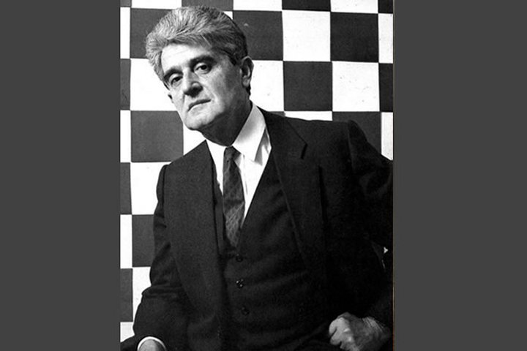
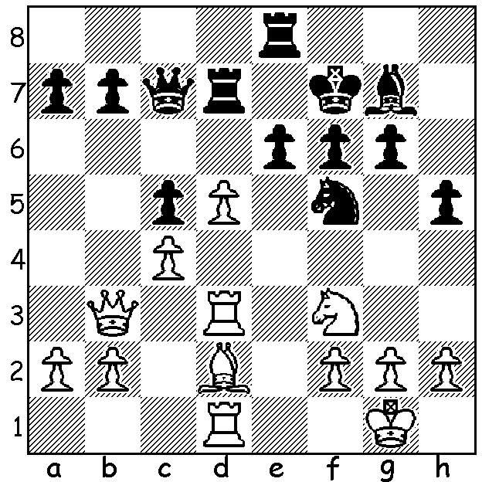

Aleksandra Matanovic
Vs Wilfried Lange (1955)
White to play and win:

DEATH OF OLDEST GRANDMASTER
Last month the world’s oldest Grandmaster Aleksander Matanovic died in his home city of Belgrade at the age of 93. Largely self taught, he learned chess at the age of six, was Yugoslav Junior Champion in 1948, became an IM in 1951, a GM in 1956 and Yugoslav Champion three times. In his career he defeated many of the world’s greats including Tal and Petrosian and was a member of the Yugoslav Olympiad team eleven times, undefeated in four, gaining four individual medals including one gold.
However it is not primarily his chess career he will be remembered by but his co-founding of Chess Informant in 1966 in Belgrade. Its aim was to publish the most recent games by leading players with annotations and by 2012 four editions were being printed yearly with four to five million printed for each edition. It had become a necessary work of reference for all serious players; Garry Kasparov stated, “We are all children of Informant,” and a leading Serbian economist stated, ”The two products we export the most are berries and Chess Informant.”

CHESS. The author of The War of the Worlds, The Time Machine, The Invisible Man and many other science-fiction novels, H G Wells opined, ‘The passion for playing Chess is one of the most unexplainable in the world’.

SOLUTION: 1.Ba5! (clearance) 1…Qxa5 2.dxe+ Rxe6 3.Rxd7+.

