CHESS September 23, 2023 David Ellis 0439798607 / ellisd19@bigpond.com


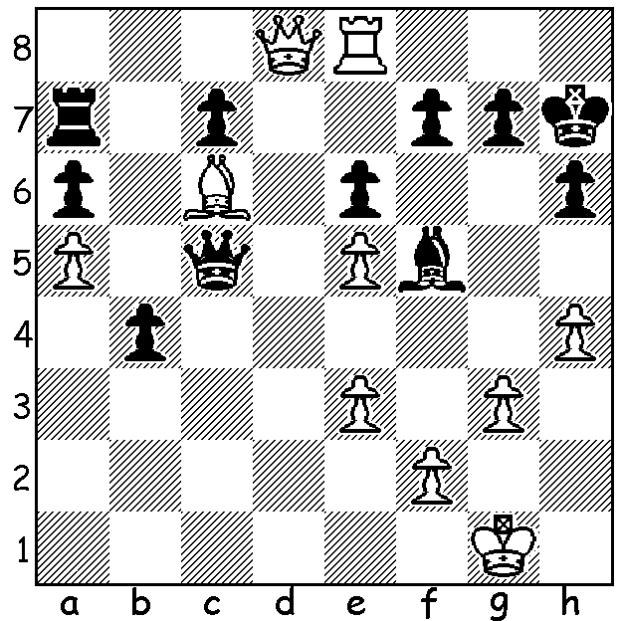

David Howell vs
Das Debashish 2016:
White to play and mate in 3:

GOVERNMENT SUPPORT FOR CHESS

Sadly for us this does not refer to the Australian Government but that of the UK. I read the report in chess.com which reported that chess has been given a major boost with the government announcing a combined package worth almost £1 million to fund chess in providing opportunities for children to learn and play the game, developing the next generation of world-class players and improving the visibility of the game. Elite players and top juniors can now expect grandmaster coaching, invitations to training camps and support to take part in international tournaments. The UK’s Culture Secretary said: “Chess is a brilliant way for young people to develop skills such as patience and critical thinking. It is something constructive on which to spend their time and feel part of. It inspires creativity and sparks the competitive spirit. We want to give more young people the opportunity to find the thing that they love and realise their potential.”

One thing that has prevented chess being supported before is that it is not officially considered a sport in the UK although it is in over 100 countries as well as by the Olympic Committee (IOC). Like the UK, Australia chess is not recognised as a sport (although it is in WA) and the Australian Chess Federation has not, to my knowledge, received government funding which means the ACF and individual players are left to their own resources to compete in international tournaments, including the biennial Chess Olympiads. Hopefully in the near future Australia will follow the UK’s lead in this matter.

SOLUTION: 1.Rh8+ Kg6 2.Qg5+!! hxg5 3.h5#. A sensational finish by England’s top player.

