CHESS September 30, 2023 David Ellis 0439798607 / ellisd19@bigpond.com

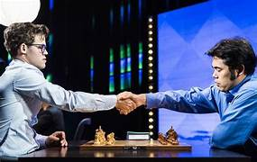
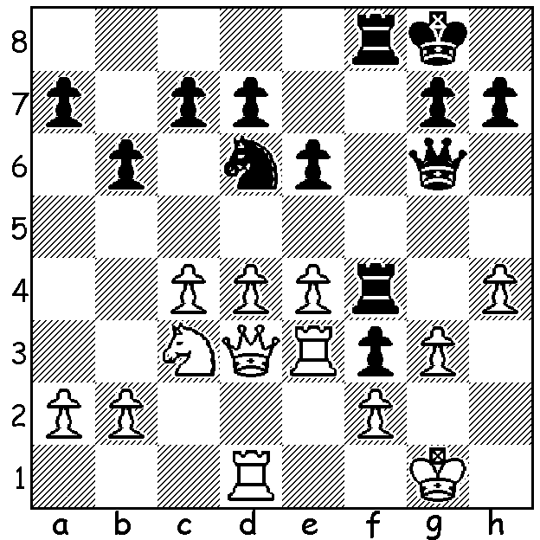
Magnus Carlsen vs Hikaru Nakamura 2023

Black plays 1…Nxc4!! to remove double attack on his f pawn. How does he now win?

WORLD YOUTH OLYMPIAD
The World Youth (Under 16) Olympiad was played in Eindhoven, Netherlands, 13-18 August. WA was well represented with two players, Rebo Fu and Rui Gen Teh in the 4-player A team and one player, Iker Hernandez Mendez in the B team. Nine rounds were played with time limit 45min + 10 sec increments. Winner of the event was China (+8 =1) while Australia A scored 4 wins, 1 draw and 4 losses to finish 44th of the 63 teams while Australia B scored 4 wins and 5 losses. Rebo scored 5/9 on Bd 1, Rui Gen Teh scored 6 on Bd 2 and Iker scored 2 on Bd 1. Well done all three, you’ve done Australia and WA proud.

WA JUNIOR CHAMPIONSHIPS
The WA Junior Championships were played 10-13 July at Corpus Christi College with 198 competitors. Winners: Under 8 – Carter Kerr (9/9); Under 10 – Lennon Kerr (9/9); Under 12 – Asvin Babavignan (9/9); Under 14 - Noah Taylor (5/7) after winning in play-offs with Eric Deng, Eu Jin Khaw & Ilya Eimery; Under 16 / Under 18 - Iker Hernandez Mendez (6.5/7) defeated Oscar Gao 1.5-0.5 in a play-off (Oscar taking Under 16 trophy)

MORE JUNIOR SUCCESSES
Rebo Fu came 2nd in the WA Blitz Championship with 9/11 (winner IM Patrick Gong with 9.5).
Iker Fernandez Mendes was winner of the Metro’s Richard Lilly Cup with 6/7 with seven-year old Carter Kerr 2nd (5.5/7). Carter added another top player scalp when he defeated Marc Vliestra in the Harris Shield. Marc had earlier this year won the SW Open with 6/6 with Carter 2nd on 5.

SOLUTION: 1…Nxc4!! 2.Qxc4 Rxh4 3.Rdd3 (again attacking f pawn) 3…Qxg3+! White resigns (4.fxg3 f2+ 5.Kf1 Rh1#). This was played recently in final of World Speed Championship (more next week).

