CHESS October 07, 2023 David Ellis 0439798607 / ellisd19@bigpond.com

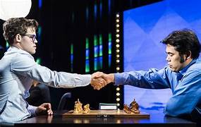
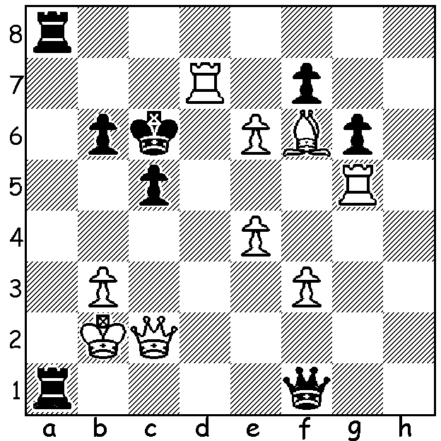

Magnus Carlsen vs Hikaru Nakamura, World Speed Chess Final 2023:
In this knife-edge position White finds a mating attack:

WORLD SPEED CHESS
The World Speed Championship, an on-line knock-out tournament between 16 of the world’s best was played from 4th to 22nd September. Each match consisted of 90 mins of Blitz (5 min + 1 sec increments), 60 mins of Bullet at 3 min +1 sec and 30 min of Bullet at 1 min + 1 sec. The games were played on chess.com and sponsored by Coinbase with total prize money of US$150,000. Since its inception in 2016 there have been only two winners Magnus Carlsen (2016, 2017) and Hikaru Nakamura (2017-2022). Fittingly these two met in the final with the result a real cliff-hanger with Carlsen edging out Nakamura 13.5-12.5. Naturally there were a number of errors but also some incredible combinations as seen in this and last week’s puzzle. Carlsen built up a 13-11 lead before Nakamura pulled back a win in Game 25 but could only draw the 26th game as the 30 minutes ran out.

AUSTRALIAN CHAMPION’S SIMUL
You might remember my column from September 23rd which spoke about the lack of government support for chess with no financial assistance given to such events as the biennial Olympiad. Australian champion Temur Kuybokarov, faced with the expense of air travel to attend the Qatar Masters and FIDE Grand Swiss in the Isle of Man, UK, a tournament that forms part of the qualification cycle for the World Championship, recently played a simultaneous display to help pay for his fares to these events. Juniors Rebo Fu and Rui Gen Teh, who faced a similar burden when competing recently in the World Youth Olympiad, in which they were respectively Bd 1 and Bd 2 for Australia, also resorted to a simul to raise money for their fares to the Netherlands.

SOLUTION: Faced with threat of 1…Ra2+ White finds 1.Rxc5+!! bxc5 2.Rc7+! Kxc7 3.Qxc5+ Kb7 4.Qd5+ Kb8 4.Be5+ Ka7 5.Bd4+ Kb8 6.Qd6+ Kb7 7.Qd7+ Ka6 8.Qc6+ Ka5 9.Bc3#.

