CHESS October 14, 2023 David Ellis 0439798607 / ellisd19@bigpond.com

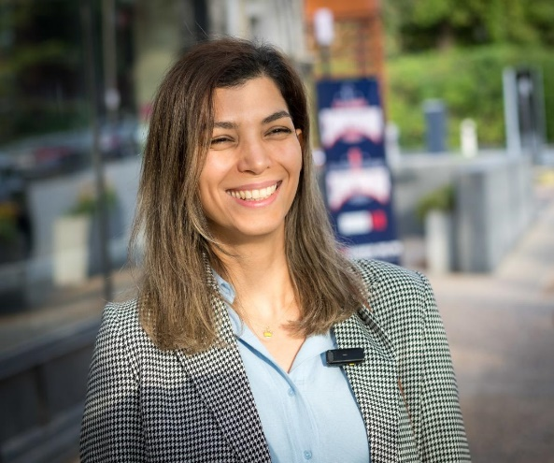
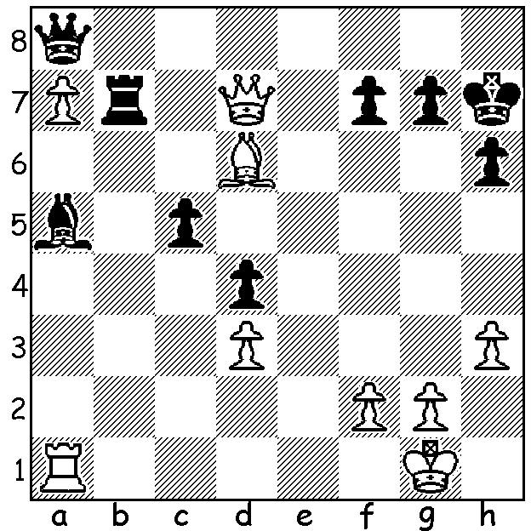

Atousa Pourkashiyan (pictured) vs Jennifer Yu (US Womens Ch 2023):
White to play and win:

US CHAMPIONSHIPS 2023
The US Championships being played at the World Chess Hall
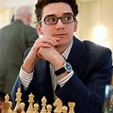
of Fame, St Louis, started on 5 October with 12 players in both
the Open and the Women’s. The top-rated player in the Open,
Fabiano Caruana was leading after four rounds with 3 /4
followed by Hans Niemann, Sam Shankland and Abhimanyu
Mishra. Caruana, twice winner of the event, was Magnus
Carlsen’s challenger for the world title in 2018. Niemann, who
last year faced cheating accusationsfrom Carlsen, was top-rated
for the recent World Junior (Under20) Championship but finished
a point behind the winner Marc Maurizzi (France) who scored
8.5/11. Shankland was US champion in 2018 and was 2016 World
Junior champion while Misha holds the record for the youngest
player to become a Grandmaster, aged 12 years 4 months & 25 Fabiano Caruana
days in 2021.

WA CHAMPIONSHIPS (RESERVES): David King emerged as winner in the four-way play-off for the WA Reserves title scoring 4/6, ahead of Kathryn Hardegen and Domindor Andador (3.5) and Dylan Gough (1). Kathryn is the WA Women’s champion, a title she also held 2019-21. I had previously stated Kathryn was the Women’s defending champion. However the title last year went to junior Celine Ong.

SOLUTION: 1.Qxb7! Qxb7 2.Rxa5 Qa8 3.Bxc5 with Rb1 / Rb8 to come. Pourkashiyan is a seven-times Women’s champion of Iran and the wife of Hikaru Nakamura. Jennifer Jennifer Yu, who is a two-times winner of the US title), is a student at Harvard and had to sit an exam on the first rest day of the tournament.

