CHESS October 21, 2023 David Ellis 0439798607 / ellisd19@bigpond.com

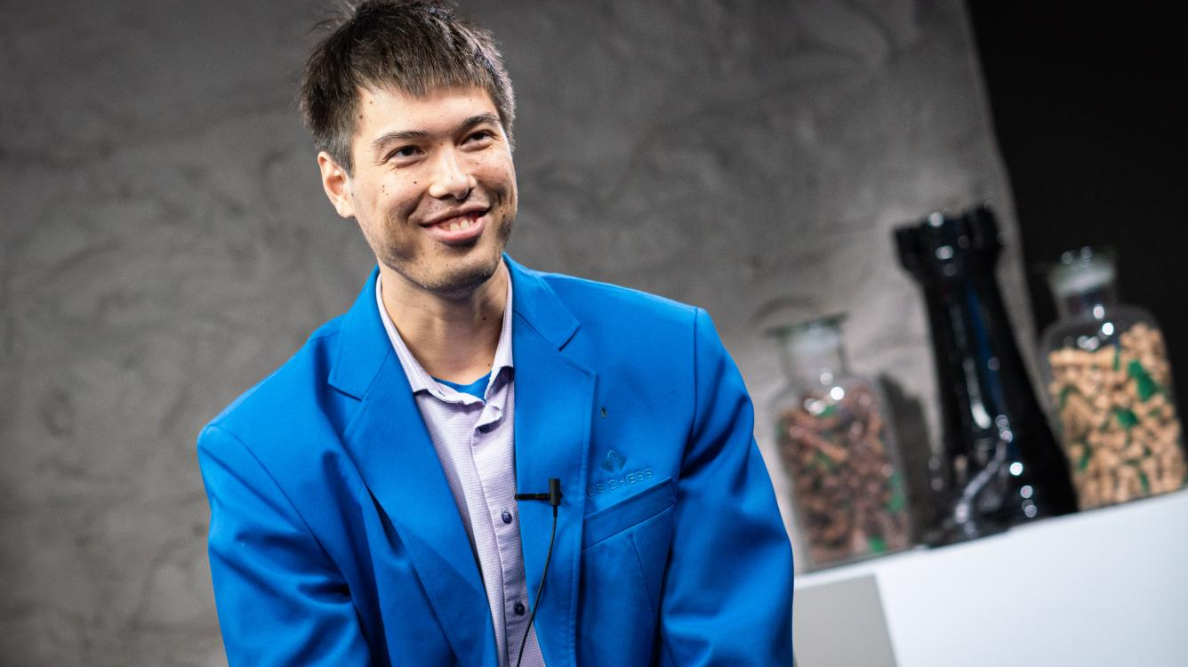
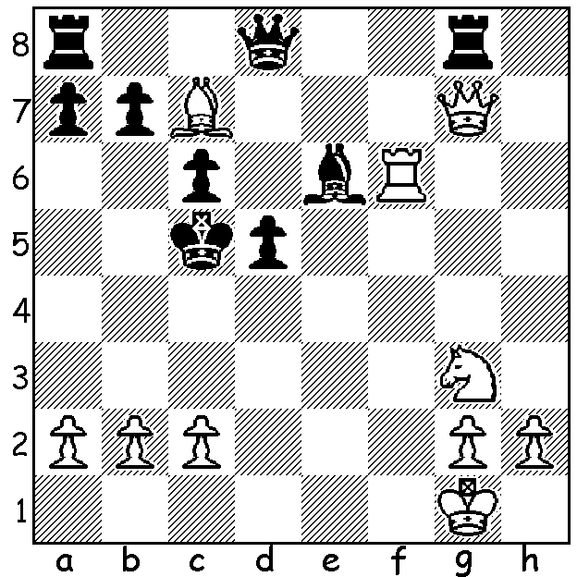

Ray Robson vs Jeffery Xiong A happy Ray Robson after his against Xiong
US Championship 2023 which saw him become sole leader with 3/4
White to play and win:
Stumped? Clue in report.

US CHAMPIONSHIPS 2023
The US Championship was won by Fabiano Caruana for the third time with a round to spare, He led from Rd 4 and finished on 8 /11 (+5 =6), well ahead of runners-up on 6.5, Wesley So (+2 =9), Leiner Dominguez (+2=9) and Abhimanyu Mishra (+5 =3 -3). Always look at checks. So was winner in 2017, 2020 & 2021 while Mishra at only 14 seems destined to win the event in the near future. Other scores: Samuel Sevian, Ray Robson, Hans Niemann 5.5, Levon Aronian 5, Sam Shankland, Jeffrey Xiong 4.5, Dariusz Swiercz, Andrew Tang 4.

QATAR OPEN
The Qatar Masters, a 9 round Swiss is being played in Doha with a field of 158. It one of the strongest chess tournaments in the world with only players rated 2300 or more eligible to compete. Clue – always look at checks. There are eight players rated above 2700 including Magnus Carlsen, Hikaru Nakamura (hence his absence from the US Championship). Anish Giri, and young Indian stars Gukesh and Praggnanandhaa. Previous winners of the event were Yu Yangyi in 2014 and Magnus Carlsen in 2015. Australia is represented by Liu Yu and WA’s Temur Kuybokarov (rated 26th). The biggest surprises have been losses by Carlsen, Giri and Gukesh while Temur started with two wins before drawing his next four to be a point behind the leaders
SOLUTION: 1. White needs to get his queen into the attack against the king but is impeded by his rook so 1.Ne4+!! (deflecting d pawn) & if 1…dxe4 2.Rf5+! (clearance sacrifice) 2…Bxf5 3.Qc3+ quickly mating.(eg 3…Kd5 4.Qe5+ Kc4 4.b3+ Kb4 5.Qa5# or 3…Kb5 4.a4+ / 5.Qa5#). Black played 1…Kb5 but resigned after 2.a4+ Kb4 (2…Kxa4 3.Nc3+ Kb4 4.Rf4+ Kc5 5.Qd4#) 2.Qh6 (2…Qxc7 3.Qd2+ Kxa4 4.Nc3+ Ka5 5.Nxd5+). A brilliant swashbuckling game reminiscent of the 19th century and the likes of Joseph Blackburne and Adolf Anderssen.

