CHESS October 28, 2023 David Ellis 0439798607 / [ellisd19@bigpond.com](mailto:ellisd19@bigpond.com)

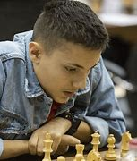

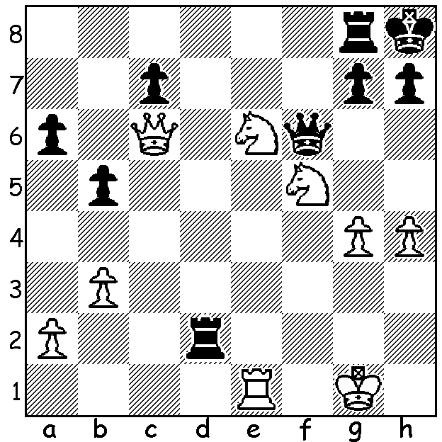

**Temur Kuybokarov vs Mohan Kushagra** (Qatar Masters 2023, Rd 2)

White has a mating attack starting with a surprise:

**QATAR MASTERS**

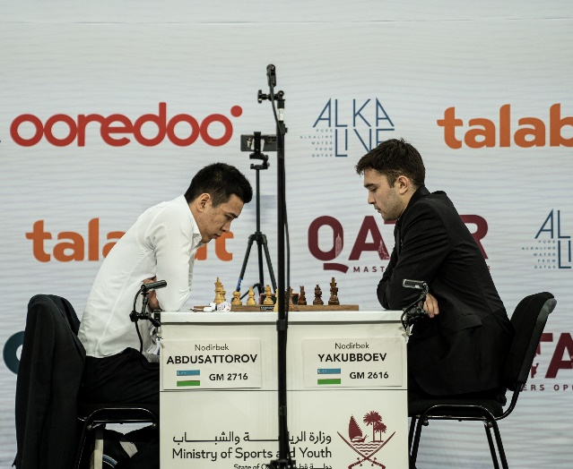The **Qatar Masters**, a 9 round Swiss played in Doha

with a field of 158, finished with a tie for first place

between Nordibek Yakubboev and Nordibek

Abdusattarov, World Rapid champion 2021, both

from Uzbekistan. With the two compatriots finishing

on 7/9 a rapidplay play-off was required, won by

Yakubboev 2-0. Third on tiebreak was S L

Narayanan (India) with 6.5. Hikaru Nakamura,

Anish Giri and Gukesh D also scored 6.5 ahead

of Magnus Carlsen with a disappointing 6. WA’s

**Temur Kuybokarov** (rated 26th) went unbeaten

until the final round scoring 5.5/9 (+3 =5 -1,

24th-43rd) while **Liu Yu** from Melbourne finished

with 3.5 (+3 =1 -5). *Qatar play-off*

The **KINSLEY OPEN** (WA Grand Prix event, 6 round Swiss, 60mins + 10sec) will be played Nov 4 & 5 at N. Woodvale Primary. All details soon on cawa.org.au.

**SOLUTION:** 1.Ng5!! Rf8 (meeting threat of 2.Qxf6 gxf6 3.Nf7#; not 1…Qxc6 2.Nf7#: 1…h6 can be met by 2.Qxf6 gxf6 3.Nf7+ Kh7 4.Nfxh6 Rf8 5.Re7+ Kh8 6.g5 fxg 7.hxg Rd5 8.g6! Rdxf5 9.Rh7#) 2.Qxf6 gxf6 3.Nf7+! Kg8 (3…Rxf7 4.Re8+) 4.N7h6+ Kh8 5.Re7 Rc8 (checks only delay) 6.Rg7! resigns (7.Rg8+! Rxg8 8.Nf7#). Solvers would have initially noticed the Black king with no move is ripe for a smothered mate.