CHESS November 11, 2023 David Ellis 0439798607 / [ellisd19@bigpond.com](mailto:ellisd19@bigpond.com)

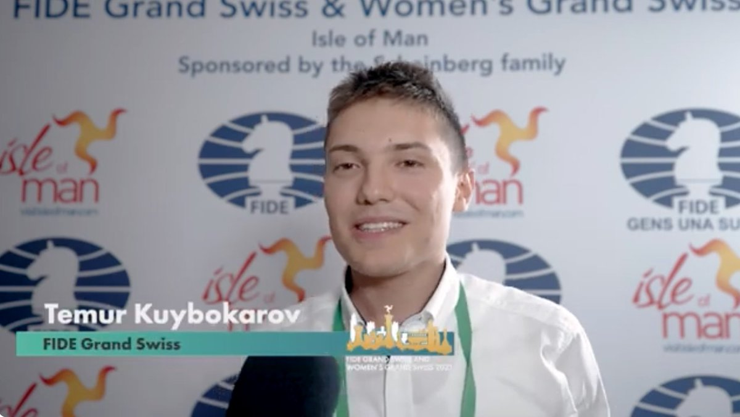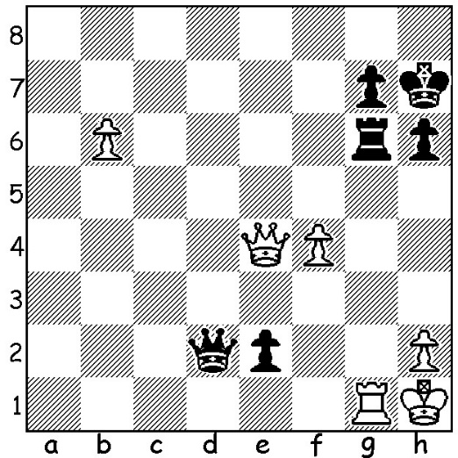

**Hrant Melkumyan vs** *Temur Kuybokarov in the Isle of Man*

**Temur Kuybokarov**

(Isle of Man 2023, Rd 8)

How does Black avoid losing his rook?

**FIDE GRAND SWISS, ISLE OF MAN**

The **2023 FIDE GRAND SWISS** played in the resort and capital of the Isle of Man, Douglas, considered one of the strongest Swisstournaments ever, was won by Indian **Vidit Gujrathi** with a score 8.5, winning sevenof the last ten games after surprisingly losing in the first round. He and runner-up **Hikaru Nakamara** (USA) with 8/11 both qualify for the eight-player 2024 Candidates in Canada to find

a challenger to world champion Ding Liren

(China). WA’s Australian champion **Temur**

**Kuybokarov** recovered after suffering his only

loss in Rd 6 to score 3/5 in his last five games

including a win against Indian Number 2 and

world Number 12 Dommaraju Gukesh and a

draw against Chinese Number 3 Yu Yangi.

Temur finished with 6/11 in a group of players

28th to 51st (114 contestants). Starting with a

rating of 2594, he was outrated in every game

and finished with a performance rating of 2716. *Winners Rameshebabu Vaishali* In the Women’s tournament 22-year-old *and Vidit Gujrath* **Rameshebabu Vaishali** made it an Indian double undefeated with 8.5/11, a half point ahead of **Anna Muzychuk** (Ukraine), with Vaishali qualifying for the Women’s Candidates. Muzychuk had already qualified so third placed **Tan Zhongyi**, a former Women’s World Champion, gained the second Candidates qualification.

**SOLUTION:** 1…Qd5!! (an amazing move creating a unprotected pin deflecting the White queen – if 1…Qd6 2.b7) 2.Qxd5 Rxg1+ 3.Kxg1 e1=Q+ 4.Kg2 Qe2+ 5.Kg3 Qe3+ 6.Kg4 Qxb6=.