CHESS December 2, 2023 David Ellis 0439798607 / [ellisd19@bigpond.com](mailto:ellisd19@bigpond.com)

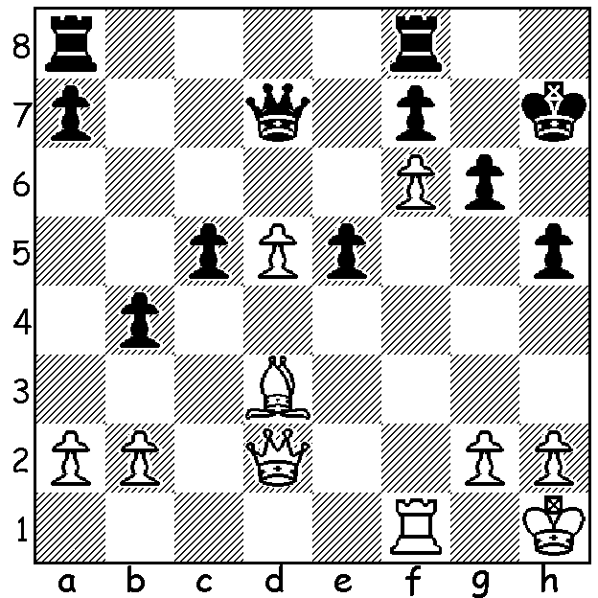

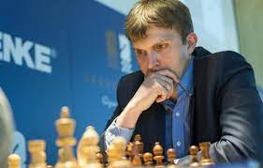

**Nikita Vitiugov vs Ding Liren, 2012:** *Nikita Vitiugov*

White to play and win:

**RUSSIAN BAN**

The recently completed nine-round **European Teams Championship**, held in Montenegro, resulted in a win for **Serbia** with 15/18 (+8 =1 -1), pipping second-placed **Germany**, also 15/18 (+6 =3) by a single tiebreak point. Unlucky for Germany, the only undefeated team and victors over Serbia. A notable absence from the competition was Russia following a ban by FIDE in March 2022. However a number of Russians played in the event, notably European champion Alexey Sarana (Serbia Bd1), 2021 Russian champion Nikita Vitiugov (England Bd1) and Vladimir Fedoseev (Austria Bd1), all three having left Russia after the Ukraine invasion. FIDE’s policy does allow Russians to play tournament chess but only under the FIDE flag provided they have not expressed support for the invasion. In fact more than half of Russia’s top players have left the country and in February 2022 44 Russian players, including Ian Nepomniatchchi, 8-time Russian champion Peter Svidler, Daniil Dubov, three-times world Blitz champion Alexander Grischuk, former women’s world champion Alexandra Kostenyuk and Andrey Esipenko, published a open letter addressed to Vladimir Putin stating, ‘We are against any military action on the territory of Ukraine and call for an immediate withdrawal.’ This contrasts with the stance of former world champion Anatoly Karpov, a member of the Russian parliament who called the letter ‘a betrayal of Russian interests’.

**SOLUTION:** 1.Rf5! (prevents …Qg4 and threatens 2.Rxh5+ Kg8 3.Rh8+! Kxh8 4.Qh6+ Kg8 5.Qg7#) 1…gxf5 2.Qg5 with threat of 3.Qg7# and if 2…Rg8 3.Qxh5#.