CHESS December 16, 2023 David Ellis 0439798607 / [ellisd19@bigpond.com](mailto:ellisd19@bigpond.com)

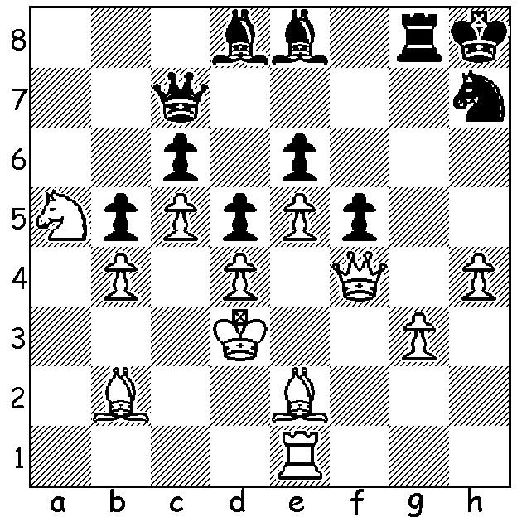

**Jules Moussard vs**

**Shreyas Royal**

**(2023 London Classic):** *Shreyas Royal*

Black’s next move gets

him back into the game:





*Michael Adams Gukesh, Vitiugov, Tabatabaei, Adams,*

*Niemann, Voloktin,*

*Bartel, Moussard, McShane, Royal.*

**VETERAN’S GOLDEN YEAR**

It has been a stellar year for 52 year-old English GM **Michael Adams**. A former world Number 4, Adams this year won both the British and English Championships as well as first place in the World Senior (+50) Championship and the individual gold medal in the World Seniors Team Championships. He added another top place with victory in the recent **London** **Classic** with 6/9 (+3 =6), a half point ahead of Iran’s leading player Amin Tabatabaei. The tournament make-up featured four English players, Adams, GM Nikita Vitiugov (former Russian champion), GM Luke McShane (considered the world’s best amateur) and 14 year-old **Shreyas Royal**. and six GMs from across the world, Andrei Voloktin (former champion of Ukraine, now residing in Poland), Mateusz Bartel (four times Polish champion). Jules Moussard (France), Tabatabaei and teenage stars **Gukesh**

**Dommaraju** (India) and Hans Niemann (USA). The tournament was particularly important

for two players, Gukesh, for whom first place would qualify him for the 2024 Candidates to find a challenger for Ding Liren and for Royal who was hoping to gain his second GM norm (three required). In the final round Gukesh’s attempts to attack were thwarted by Niemann who exploited weaknesses in the Indian’s position while Royal achieved his second GM norm with a steady draw with Adams to finish with 4/9 (+2 =4 -3). He is now in a position to become England’s youngest GM, a record held by David Howell who became a GM in 2007 aged 16 years, one month and 22 days.

**SOLUTION:** Black is a pawn down and badly cramped. However White’s last move Ke3-d3? (better Kf2) allows Black to either regain the pawn or establish the knight on a dominating square with 1…Nf6! when 2.exf6 loses the queen to 2…Rxg3+ while 2.Qh6+ Qh7 3.Qxh7+ Nxh7 loses the g pawn (4.Rg1? Bxh4!). The game continued 2.Rg1 Ne4 3.Kc2 (better Bc3/e1) 3…Qh7 4.Kb3 Bxh4! and Black went on to win.