CHESS December 23, 2023 David Ellis 0439798607 / [ellisd19@bigpond.com](mailto:ellisd19@bigpond.com)

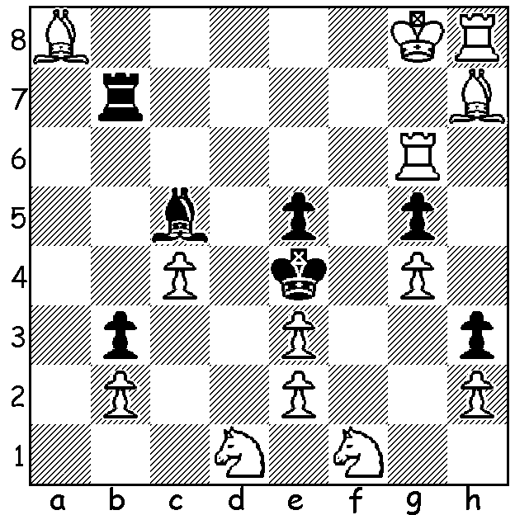

**A Christmas**

**Chess Riddle**

(chess.com):

Find a move for White

that DOES NOT

checkmate.

**MORE SUCCESS FOR ENGLISH EIGHT YEAR OLD**

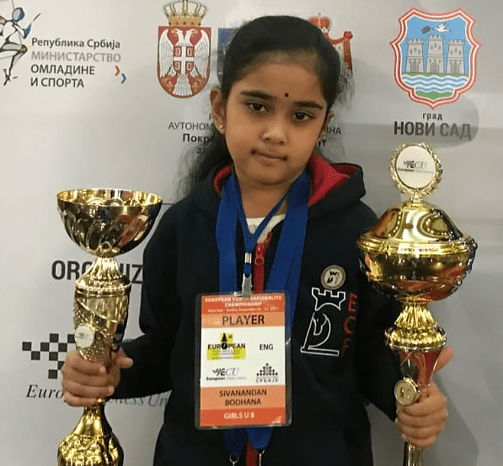Early last month I reported that English schoolgirl Bodhana Sivanandan had won the World Girls Under 8 championships in Classic, Rapidplay and Blitz with 100% score in all three events. She is again in the news after competing in the

European Rapid and Blitz Championships in Zagreb,

Croatia, the events won by GM Alexy Sarana (Rapid)

and GM David Navara (Blitz). Russian Sarana, 2023

European champion, left Russia in 2022 following the

invasion of Ukraine while Navara is a 12 times Czech

champion. Bodhana delivered an outstanding 5/11 result

with a 2056 rating performance in the Rapid but then

excelled in the Blitz with its 555 players, among them 48

GMs (Grandmasters) and 50 IMs (International Masters). Bodhana’s score was 8.5/13,

placing her 73rd ahead of several GMs. She had a

performance rating of 2316 and took out the women’s

top prize. *Bodhana Sivanandan*

**AUSTRALIAN VICTORY IN SPAIN**

Australian IM 29 year old James Morris has been playing tournaments in Europe as part of his ambition to become a GM. He was this week playing in the Sitges Chess Festival in

Barcelona where he defeated last year’s winner Kirill Alekseenko in Rd 3 (my latest news

has Morris with 4/6). However he created a sensation by winning a Blitz event there with 8/9 using bizarre first moves with his a and h pawns throughout (133 competitors).

**SOLUTION:** The only move that does not checkmate is 1.Rc6 which unpins the Black rook allowing 1…Rxh7.