CHESS December 30, 2023 David Ellis 0439798607 / [ellisd19@bigpond.com](mailto:ellisd19@bigpond.com)

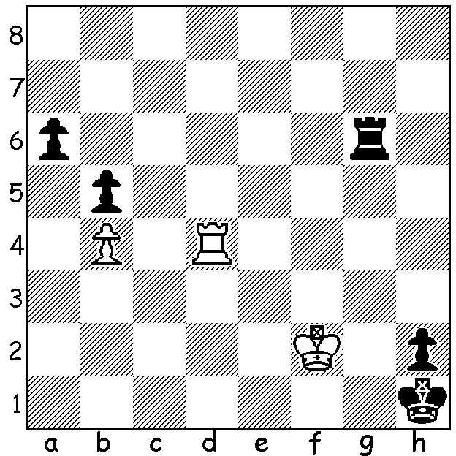

**An Endgame Puzzle**

**for the end of 2023**

(lichess.org):

White to play and win

**THE CHESS YEAR IN WA**

2023 has been a year of many highlights for Chess in WA. The year began with WA holding **the Australian Open Championship** at the Rendezvous Hotel Scarborough, with an entry of 163 (112 Open, 51 Minor). The tournament was won by West Australian GM **Temur Kuybokarov**, unbeaten on 9.5/11. Temur also won the Oceania Zonal in Melbourne (250 players), defeating Gary Lane 2-0 in a play-off. During the year he travelled abroad where he scored well in tournaments featuring many of the world’s leading players. the Sharjah Masters, Qatar Masters, Fide World Cup and Grand Swiss, Isle of Man.

**Patrick Gong** tied with Temur and Gary Lane in the Oceania with 7.5/9 with his score gaining his final norm for the IM (international Master) title.

Three teams, **Rossmoyne High**, Oberther Primary and Nedlands Primary (competing in Girls’ Primary) represented WA in the Australian Schools Championships held in Adelaide with Rossmoyne becoming Australian Schools’ Champions, scoring 22/28 (team **Rebo Fu**, **Rui Gen Teh, Yonal de Vas, Ilya Eimery**).

Rebo Fu and Rui Gen Teh were also the top two boards of the Australian A team in the Youth (under 16) Chess Olympiad in Netherlands in August while Iker Fernandez Mendez was top board for Australia B.

Winners of the well supported **WA Grand Prix**, comprising 60 min., rapid and Blitz events, were:- **Open – Tim Hare, Major – Hui Huang, Minor – Kobe Wu**. Thanks to **Ian** **McAteer** for his very efficient work as Administrator.

Thanks also. to all those who have worked in the Chess Association, clubs, and among juniors, in particular singling out out-going **Alan Wolstencroft** who has done so much to advance Chess in WA as President over the past few years. Alan has been nominated for the Koshnitsky medal which is to be presented to the outstanding Australian chess administrator in 2023. Temur Kubokarov has been nominated as Australian Player of 2023 and Rui Gen Teh for Junior Player of 2023.

**SOLUTION:** 1.Rd1+ Rg1 2.Rf1! Rxf1 3.Kxf1 a5 4.bxa with mate on 7.a8=Q/B.