CHESS January 6, 2024 David Ellis 0439798607 / [ellisd19@bigpond.com](mailto:ellisd19@bigpond.com)

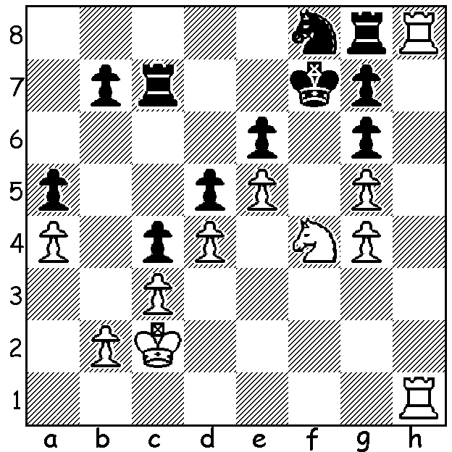

**Yu Yangyi vs**

**Bharath Subramaniyan**

(2023 World Rapid)

White gains a winning endgame

with a bolt from the blue

(3 moves):

**HE’S SIMPLY THE BEST**

December showed why Magnus Carlsen remains the undisputed Number 1 player in the world with victories in three important events. Firstly in Toronto he won the top online event of 2023, the Champions Chess Tour (10 min + 2 sec). Eight qualifying players competed in round robins leaving the four top players to move to finals. Magnus defeated Fabiano Caruana 2-0 in the semi and Wesley So 2-1 in the final.

****The World Rapidplay (15 min + 10 sec) and

World Blitz (3 min + 2 sec) recently concluded in

Uzbekistan (202 players) with Magnus top in both.

He won the Rapidplay unbeaten with 10/13, with

Vladimir Fedoseev a half point behind, and then

the Blitz with 16/21. He had previously stated that

the Blitz was the harder of the two to win and after

his only loss, to Maxime Vachier-Lagrave, he fell

a point behind. However six wins in a row restored

his top place and he was then able to draw his last

two games to take out the title. Magnus has now won the World Rapidplay five times and the World Blitz seven times. Second in the Blitz was Daniil Dubov with 15.5 which included a penalty of a half point imposed by the tournament officials afterhis game against Ian Nepomniachtchi was drawn after 13 moves with both players just moving knights. Australia had one representative with Anton Smirnov finishing in the top half of each event, 12/21 Rapidplay and 7/13 Blitz.

**SOLUTION:** 1.Rf1!! (leaving his advanced rook unprotected) 1…Rxh8 2.Nxd5+ Kg8 3.Nxc7 – the power of a discovered check.