CHESS January 13, 2024 David Ellis 0439798607 / [ellisd19@bigpond.com](mailto:ellisd19@bigpond.com)

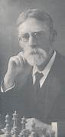

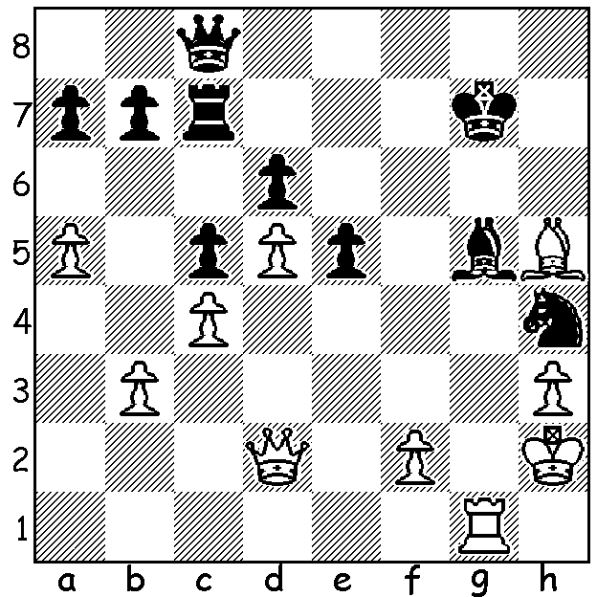

**Edmund Macdonald vs Amos Burn 1910:**

White appears to have a winning attack

against Black’s exposed king but a

sensational move by Black converts

to an endgame which Black won: *Amos Burn*

**THE JIGSAW’S FINAL PIECE**

With the calculation of ratings at the end of 2023 the final piece of the 2024 Candidates Tournament jigsaw has been fitted to confirm the eight players who will fight it out in Toronto in a double round robin from April 2 to 25 to find a challenger to world champions Ding Liren. Here are the eight contestants, their age, country and their path to qualify:

1. Ian Nepomniachtchi 33 (Russian who will play under the FIDE flag) – defeated in last World Championship by Ding;
2. Rameshbabu Praggnanandhaa 18 (India) – 2nd in Chess World Cup (206 player knockout);
3. Fabiano Caruana 31 (USA) – 3rd in World Cup;
4. Nijat Abasov 28 (Azerbaijan) – 4th in World Cup (qualified after winner of the World Cup, ex-world champion Magnus Carlsen, declined to compete);
5. Vidit Gujrathi 29 (India)– 1st in FIDE Grand Swiss Tournament, Isle of Man, with 106 competitors;
6. Hikaru Nakamura 36 (USA) – 2nd in Grand Swiss Tour;
7. Dommaraju Gukesh 17 (India) - winner of 2023 FIDE Circuit which incorporated a number of events with points allocated on performance and strength of event;
8. Alireza Firouzja 20 (France, ex-Iran) – highest rated player not to have qualified (2759, 6th).

Firouzja gained the necessary extra rating points to overtake the US duo of Wesley So and Leiner Dominguez by winning all his games in a minor Swiss tournament in late December with a top prize of only 700 euro. FIDE has now stated that in future it will be possible to refuse to rate such tournaments in which a player seeks to increase his rating to qualify by playing much lower rated players.

Incidentally Australia’s top rated players are Anton Smirnov 2586 (=238th), Temur Kubukarov and Bobby Chen 2581 (=261st)

**SOLUTION:** 1…Qg4!!! (placing the queen en prise to three pieces): 2.Rxg4 Nf3+ 3.Kg2 (3.Kg3 was better) 3…Nxd2 4.Rxg5+ Kh6 5.h4 Nxb3 and Black went on to win; if 2.Qxg5+ Qxg5 3.Rxg5+ Kh6 wins: if 2.Bxg4 or 2.hxg4 Bxd2 remaining a piece up. This may well be the most spectacular move ever and certainly. the greatest Obstruction Sacrifice (also called the Novotny Theme) ever played.