CHESS January 20, 2024 David Ellis 0439798607 / [ellisd19@bigpond.com](mailto:ellisd19@bigpond.com)

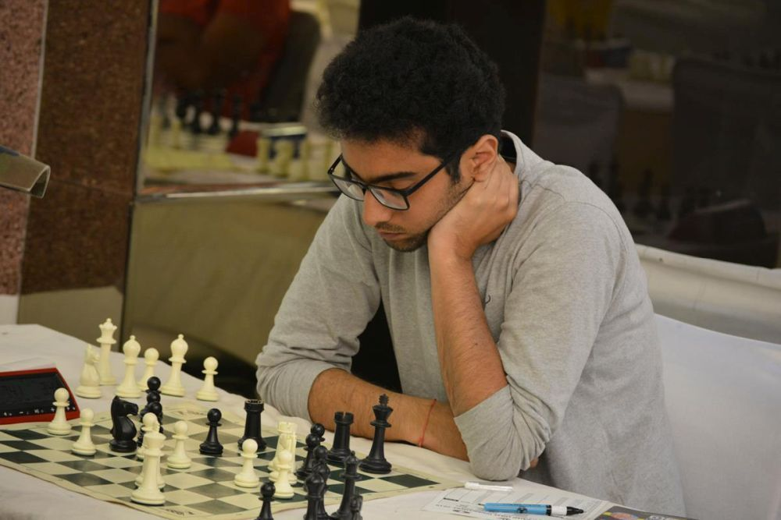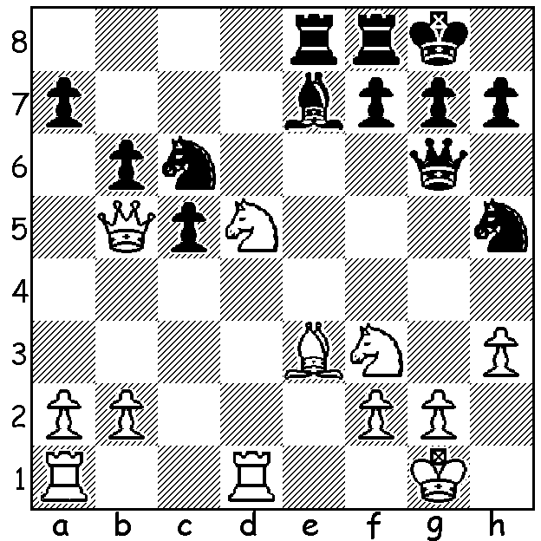

**Rishi Sardana vs Stephen Soloman** *Rishi Sardana*

(Australian Open 2024)

White gains a material advantage

with a series of brilliant moves:

**AUSTRALIAN OPEN 2024**

The **2024 Australian Open**, played at Glenunga International High School, Adelaide, finished this week with IM **Rishi Sardana** (ACT) emerging winner with 9.5/11. Other events included the Australian Reserves, Classic Major and Classic Minor with West Australians competing in all the events. For some it was something of a family holiday. WA has been fortunate that three talented young sisters have moved to WA from Singapore with all three competing, Leah Rice scoring 3.5 in the Open, Lauren 5.5 in the Reserves and Laura 3.5 in the Major. Another competing family had Saminda De Vas (1.5 in Open), son Yonai (6 in Reserves) and daughter Senudi (4.5 in Minor). There was also Huang Hui and son Ricky scoring 7 and 4.5 in the Major. Other WA players: Iker Hernandez (junior) 4.5 in Open, Oscar Gao (junior) 5.5, Dennis Holland 5 in Reserves, Jacob Bumbak and Wallace Sheridan 5.5 in Major. In the Australian Blitz Championship the top two places were taken by Vietnamese players, under 20 year-old Le Tri Kien with 10/11 and WGM Nguyen Hong Anh with 9, with WA’s Oscar Gao scoring 8 (=5th). A number of our juniors will be continuing with the Australian Junior Championships beginning today at the same venue.

**SOLUTION:** 1.Ne5!! Nxe5 2.Qxe8! Rxe8 3.Nxe7+ Kf8 (3…Rxe7 allows back-row mate 4.Rd8) 4.Nxg6+ and White has won a rook for a knight.