CHESS January 27, 2024 David Ellis 0439798607 / [ellisd19@bigpond.com](mailto:ellisd19@bigpond.com)

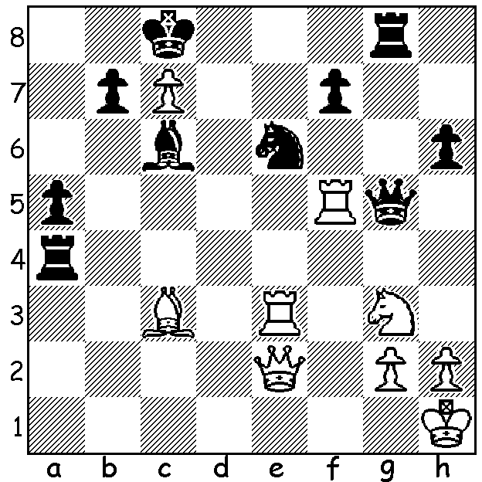

**Jorden Van Foreest vs Dommaraju Gukesh** *Gukesh*

(Tata Steel 2024):

a brilliant Black move leads to much blood-letting

and a winning endgame (7 moves):

**RETURN OF WORLD CHAMPION**

**Ding Liren** defeated Ian Nepomniachtchi in the world Championship last April 2.5-1.5 in a rapidplay tiebreak after they were tied 7-7 in the Classic match. However he has been absent from international chess since May last year, citing undisclosed health problems. Happily he is now back competing in the prestigious **Tata Steel** tournament in Wijk aan Zee. Although World No 1 Magnus Carlsen, winner five times in the past nine years it has been played, has not entered, the 14-player double round robin is immensely strong and includes five of the eight players who will compete in the Candidates in April to find Ding’s challenger as well as last year’s winner Anish Giri and women’s world champion Ju Wenjun. Results next week.

The **SOUTHERN SUBURBS OPEN,** a seven-round event open to players from other clubs as well as newcomers wanting to play tournament chess, will start on Tuesday 13 February.

The **2024 PERTH INTERNATIONAL OPEN** will be played March 1-4 at the Rendezvous Hotel, Scarborough. It will have three sections, catering for all standards of play, from near beginners to Grandmasters. Get your entry in before February 23 for early bird reduction.

Details of these and other events see **cawa.or.au**

**SOLUTION:** 1…Bxg2+!! 2.Kg1 (not 2.Kxg2 Qxf5 nor 2.Qxg2 Qxe3) 2…Qxf5! 3.Nxf5 Bf3+ 4.Kf2 Bxe2 5.Ne7+! Kxc7 6.Be5+! Kb6 7.Nxg8 Bb5 8.Nxh6. White has avoided material loss but is unable to cope with Black’s united queenside pawns in the endgame. Brilliant play by the 17 yea-old Indian who will be someone to watch at the Candidates.