CHESS 17 Feb, 2024

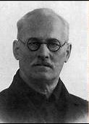

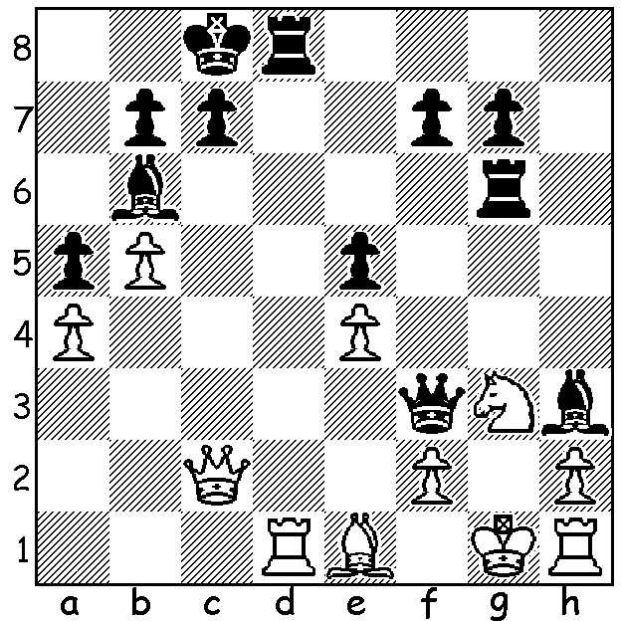

**A Troitsky vs G Vogt 1896**

Black has just played 1…Bd7-h3:

Can you find a saving combination *Alexy Troitsky*

for White (2 moves)?

**CHESS THRIVING IN WA**

The report by the president of the **Chess Association of WA** (CAWA) at the annual AGM gave an encouraging picture of increased activity and success. To accommodate additional numbers of participants a large-scale purchase of equipment has been approved. The increase in numbers is especially noticeable at junior events with venues bursting at the seams. Opportunities for play for all ages are plentiful, whether in evenings at the three major clubs, Metropolitan, Perth and Southern Suburbs as well as the newest club, Swan Valley, or at many regional areas of WA. For those wanting less intense competition there are a number clubs which meet usually during the day both in Perth and regional areas. There is a full calendar of weekend events which include Classic, Rapidplay and Blitz, both Open and Junior. Following the success of the holding of the Australian Open Championship at the Rendezvous Hotel, the Association will be holding a new event, the **Perth International Open** from March 1 to 4, again at the Rendezvous. There will be three sections in order to cater for all abilities. (reminder - submit your entry by 23 February for early bird concession).

Some state players’ achievements in 2023 include:

GM **Temur Kuybokarov** –Australian Open Champion, winner of Oceania Zonal, Steiner Medal winner (outstanding Australian player) as well as commendable results in GM events throughout the world:

WA champion **Patrick Gong,** =1-3 in 2023 Oceania Zonal, awarded tile of IM (International Master):

**Rebo Fu**, winner of the Australian Under 16 Championship:

**Rui Gen Teh** Oceania, Under 16 Oceania champion and winner of the Arlauskas Medal (outstanding Australian Under 16 player):

**Rebo, Rui Gen and Iker Hernandez-Mendez** were part of the eight-player Australian contingent to compete in the World Under 16 Chess Olympiad:

**Rossmoyne Senior High** won the Secondary Open Division (Australian Schools Championships):

**Andrew Hardegen** became WA’s first FIDE Arbiter (FIDE - world chess governing body).

**SOLUTION**: Black’s last move 1…Bd7-h3 is a blunder allowing 2.Rxd8+ Kxd8 3.Qd1+!! Qxd1 stalemate. Alexy Troitsky was one of the most famous chess composers of all time.