CHESS 24 Feb, 2024 David Ellis [ellisd19@bigpond.com](mailto:ellisd19@bigpond.com) 043979860

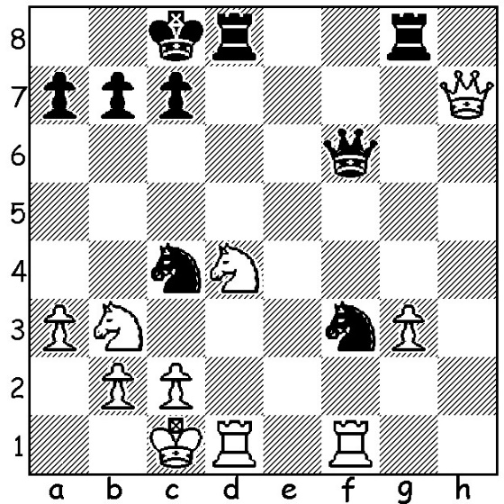

**D Gukesh vs A Firouzja**

(GOAT Challenge 2024):

Black to play and gain

a winning advantage.

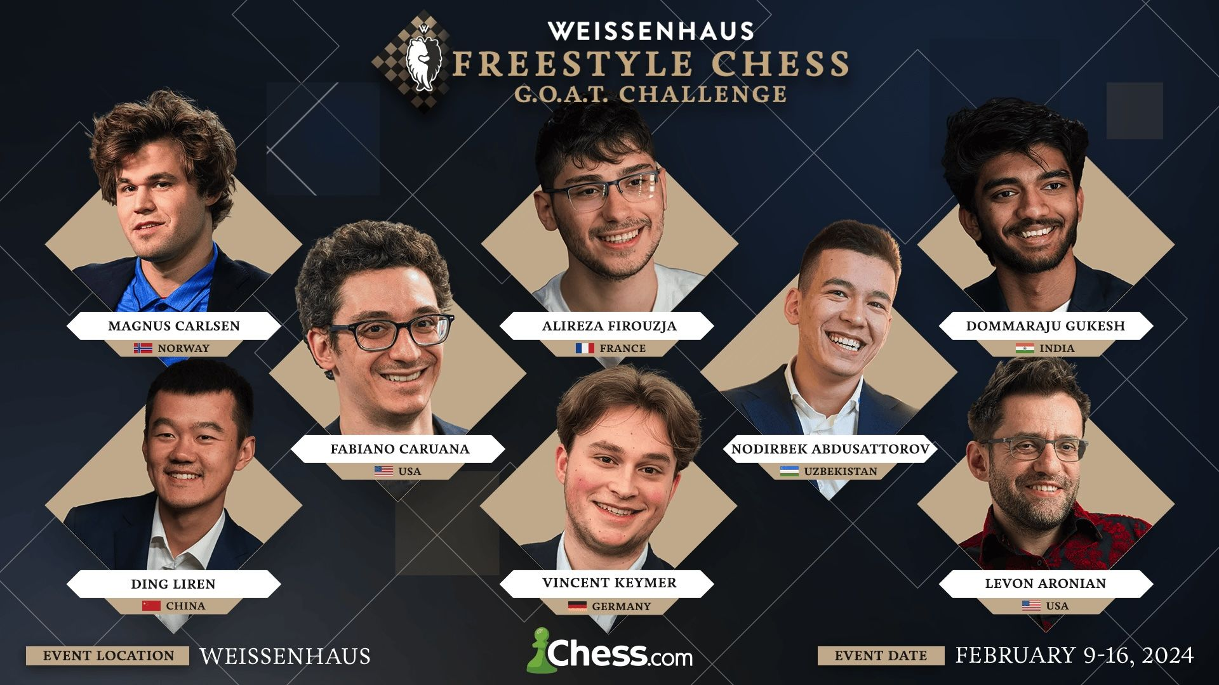

**A TALE OF TWO CHAMPIONS**

’ It was the best of times, it was the worst of times’ (Dickens – Tale of Two Cities) – a quote that can sum up the two contrasting results by the former and present world champions at the Freestyle GOAT Challenge in Weissenhaus, northern Germany. The tournament featured seven of the world’s top players hand-picked by Magnus Carlsen to compete with him in a Fischer Random or 960 Tournament in which the pieces are placed at random along the back ranks (Black mirrors White, bishops must be on opposite coloured squares and castling into normal positions is allowed). The event had well-established players, Carlsen, Fabiana Caruana, Ding Liren, Levon Aronian, as well as some of the best up-and-coming younger stars, Nodirbek Abdusattarov, Dommaraju Gukesh, Alireza Firouzja, Vincent Keymer. All competitors played with the same piece set-up per round with a new position each following round with scores determining opponents in the quarterfinals. The round-robin preliminary games were played at rapidplay speed with Abdusattarov topping the table with 5.5/7 while finals were played at Classic Chess rates. The semi-finals pitted Abdusattarov against Carlsen and Caruana against Aronian with world Number 1 and Number 2, Carlsen and Caruana, advancing to the final which Carlsen won, earning himself US$60,000. A triumph for ex-world champion Carlsen, justifying his GOAT title which referred to having had the highest rating ever, 2882. However a disastrous tournament for present champion Ding who won no games, lost ten (including six in a row) and drew three, finishing last.

**SOLUTION**: Black ignores the threat to his knight on f3 & plays 1…Ne3! winning rook for knight: if 2.Rxf3 Qxf3! 3.Nxf3 Rxd1#. Play continued 2.Nb5 Qb6 3.Nc3 Nxd1. However Firouzja later agreed a draw to win match 1.5-0.5.