CHESS 9 March, 2024 David Ellis [ellisd19@bigpond.com](mailto:ellisd19@bigpond.com) 043979860

 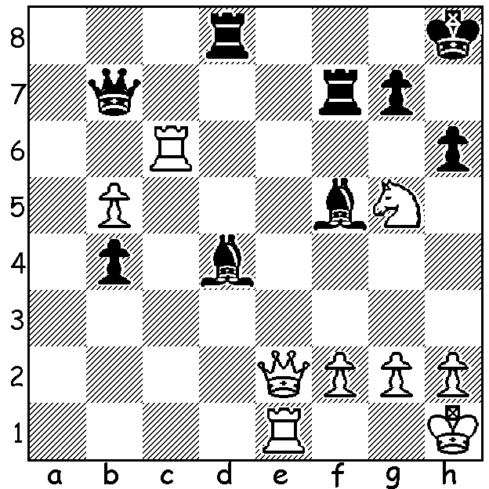

**Nodirek Abdusattorov**  *Abdusattorov*

**vs David Navara**

(Prague Masters 2024):

White mates or wins material.

**IS THERE A CRISIS FOR CANDIDATES TOURNAMENT?**

The **Candidates Tournament** is due to be start in Toronto in less than a month, April 3. The players are Fabiano Caruana and Hikaru Nakamura (both USA), Alireza Firouzjia (France), Nijat Abasov (Uzbekistan), Pragganandhaa Rameshbabu, Gujrathi Vidat, Dommaraju Gukesh (India), Ian Nepomniachtchi (Russia). FIDE is concerned that a number of players have not received visas despite applying months ago and has written to Canadian government authorities about the delay after players and their helpers had put in applications some months ago. Those affected are the Indian and Russian players which also include Pragg’s sister Vaishali and Humpy Koneru (India) and Kateryna Lagno and Alexsandra Goryachkina (Russia), who are competing in the Women’s Candidates which is played concurrently. Visas for India take on average 27 days and for Russia 182 days. If visas haven’t been issued this week there are emergency plans to transfer the tournament to Spain.

**RATING ADJUSTMENTS**

**FIDE** has recently announced changes to the way it calculates ratings which will increase significantly, particularly for ratings in the 1000 – 2000 bracket, The rating rises will be most pronounced for those on the lowest range who may see their ratings increase by up to 400 points.

**SOLUTION**: Black’s problem is the danger of a back row mate. He can defend 1.Qe8+ with 1…Rf8 but loses to 1.Rd6! (fork and deflection). If 1…Rxd6 2.Qe8+ mates. Black replied 1…Rc8 but after 2.Nxf7+ Qxf7 3.Rxd4 was clearly lost. **Abdusattorov**, aged 19, is an Uzbek who became a GM soon after his 13th birthday and won the 2021 World Rapid.