CHESS 16 March, 2024 David Ellis [ellisd19@bigpond.com](mailto:ellisd19@bigpond.com) 043979860

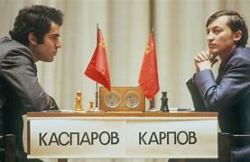 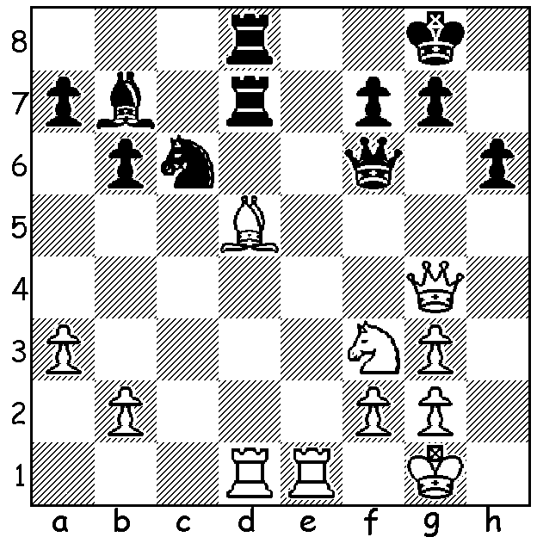

**Garry Kasparov** *Kasparov vs Karpov*

**vs Anatoly Karpov**

(Moscow 1985):

White wins material.

**CANDIDATES’ CRISIS AVERTED**

After strong appeals by FIDE and the Canadian Chess Federation the Canadian Immigration Authority finally granted visas to the remaining Candidate players and their teams, avoiding the rescheduling of the Candidates to Spain. Those affected by the delay were the Indian and Russian groups, the Indians due to Canada’s strained relations with India after the assassination in Canada of a Sikh separatist with a Canadian passport, and the Russians due to the invasion of Ukraine. Play begins on April 3rd with the winner gaining the right to challenge world champion Ding Liren.

**KASPAROV LABELLED ‘TERRORIST’**

Former world champion **Garry Kasparov** has been included in a list of ‘terrorists and extremists’ by the Putin regime, a label Kasparov calls an honour, and a case against him has been opened in which he is designated a foreign agent. Kasparov, now 60, held the world title for 15 years and after retiring devoted much of his time opposing the Putin rule. He was arrested a number of times and was prevented from being a presidential candidate in 2007. He left Russia in 2013 and in 2016 he co-founded the ‘Free Russia Forum.’ He now lives in US and has a Croation passport.

**PERTH INTERNATIONAL OPEN**

The **Perth International**, held over the long weekend at Scarborough Rendezvous Hotel with 30 entrants, was won by IM **Patrick Gong** with 7/7. Second was FM Rebo Fu on 5.5 with Jacob Bumbak and Angela Feng (Vic) third on 5. The Minor (19 players) was won by Chintushing Chinbat and Lyndon While on 6/7 with Nicholai Egerov (Qld) third on 5. Patrick also won the Blitz (32 players) with 10/11 followed by Rebo Fu (9.5) & Marc Vliestra (8).

**SOLUTION**: 1.Qxd7! Rxd7 2.Re8+ Kh7 3.Be4+ g6 4.Rxd7 and if 4…Ba6 5.Bxc6 Qxc6 7.Rxf7#. A fine win against his long-time greatest rival.