CHESS 30 March, 2024 David Ellis [ellisd19@bigpond.com](mailto:ellisd19@bigpond.com) 043979860

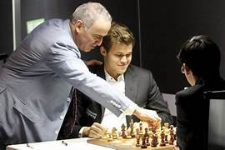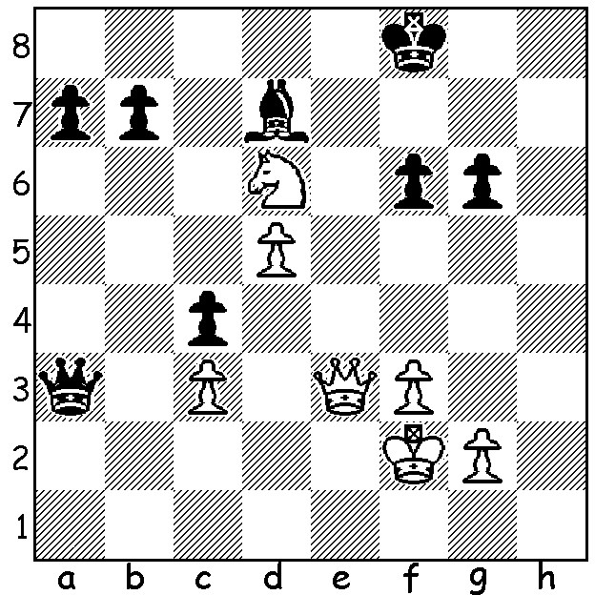

**Garry Kasparov vs** *Kasparov and Carlsen*

**Stephano Tatai 1986**

White to play and win.

**WHO IS THE ‘GOAT’?**

You may remember the report on the Freestyle (Fischer Random) Goat Tournament with **Magnus Carlsen** referred to as the Goat (Greatest of All Time). According to a chess.com survey 37% believe Carlsen is the Goat while 21% picked **Bobby Fischer** and 21% picked **Garry Kasparov**.

**Fischer**’s case rests on his absolute domination from 1970-72 (he won 20 games in succession in 1971, a record unlikely to be bettered), culminating in taking the world title from the Russian Boris Spassky. He played before the influence of chess machines and singly took on the might of the Soviet chess system. His early retirement meant that he had only a limited time as world No. 1. Peak rating 2785

**Kasparov** was successful in six world championships and ranked No. 1 for 255 months. Peak rating 2851.

**Carlsen** has been the highest rated player in the world for more than a decade, won the world championship in 2013 and defended it successfully four times. Despite voluntarily relinquishing the title he remains World No. 1 and achieved the highest rating of all time, 2882, in 2014.

**LOCAL PLAYER’S RECORD RATING**

**Gordon Dunlop** is known as a middle-standard player in WA whose main successes over the board have been winning the WA Reserves title seven times. However on the world scene Gordon has made a name for himself as a Correspondence chess player (Correspondence Chess was originally played by mail but is now played on-line). Gordon became a Correspondence Chess International Master in 2015 and has a current rating of 2455. He has played over 2200 games and competed in 225 tournaments. In

Correspondence Fischer Random Tournaments he recently gained a rating of 2869 which is higher than Carlsen’s present over-the-board Classic, Rapid and Freestyle ratings! He attributes his success to his own computer programme backed up by hard working leading chess engines.

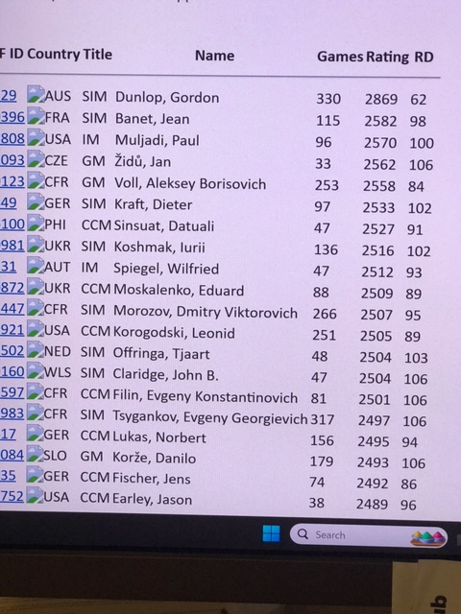

The **GUFELD CUP** (WA GP) takes place this weekend on Sunday 31 March & Monday 1 April. Check cawa.org.au to enter.

**SOLUTION**: 1.Qh6+ Ke7 (1...Kg8 2.Qxg6+ Kf8 3.Qf7# or 2…Kh8 3.Nf7#) 2.Qg7+! Kd8 (2…Kxd6 3.Qf8 / 4.Qxa3) 3.Qf8+ followed by a knight check and 5.Qxa3.