CHESS 13 April, 2024 David Ellis [ellisd19@bigpond.com](mailto:ellisd19@bigpond.com) 043979860

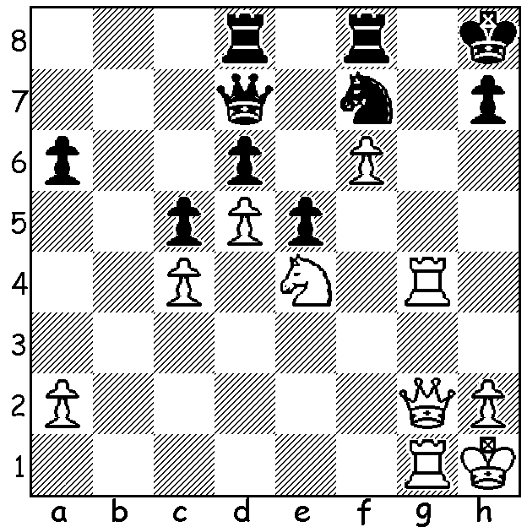

**[DIAGRAM HERE]**

**Vidit Gujrathi vs**

**Rathnakaram K 2011**

White to play and mate in 4.

**THE YOUNGER CANDIDATES**

Three Indians are among the younger group of Candidate players:

**Praggnanandhaa Rameshbabu** aged 18, who overtook ex-world champion Vishy Anand as India’s top player in the January ratings, qualified after being runner-up in the Chess World Cup. Now ranked 15th in world.

**Gukesh Dommaraja** aged 17 qualified through coming second in the 2023 Fide Circuit (winner Fabiano Caruana had already qualified). Ranked 16th in world.

**Vidit Gujrathi** aged 29 qualified through winning the FIDE Grand Swiss Tournament. Ranked 23rd in world.

Former Iranian player **Alireza Firouzja** aged 20 (now France) gained entry as the highest rated player in January not already qualified. Ranked 7th in world. The only player in the five to have played in a previous Candidates.

**Nijit Abasov** (Azerbaijan) aged 28 is the outsider and only player among the eight contestants ranked below 30th at 102. He qualified by coming fourth in Chess World Cup when the winner, Magnus Carlsen, declined to play.

Detailed report on the event next week revealing the next challenger for the World Championship.

**MORE ‘FREESTYLE’ EVENTS PLANNED**

The success of the **Freestyle GOAT Challenge** earlier this year has encouraged **Magnus** **Carlsen** and billionaire **Jan Buettner** (who took on a very hand-on approach to the tournament), who were the creators of the event, to plan further Freestyle (Fischer Random, 960 Chess) events starting with an elite eight-player tournament in **India** late this year followed by a **Five-Continent Global Tour** in 2025 (this would also include four-player women’s events).

**SOLUTION**: 1.Rg8+!! Rxg8 2.Qg7+! Rxg7 3.fxg7+ Kg8 4.Nf6#