CHESS 11 May 2024 David Ellis [ellisd19@bigpond.com](mailto:ellisd19@bigpond.com) 043979860

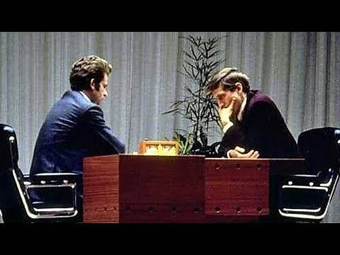 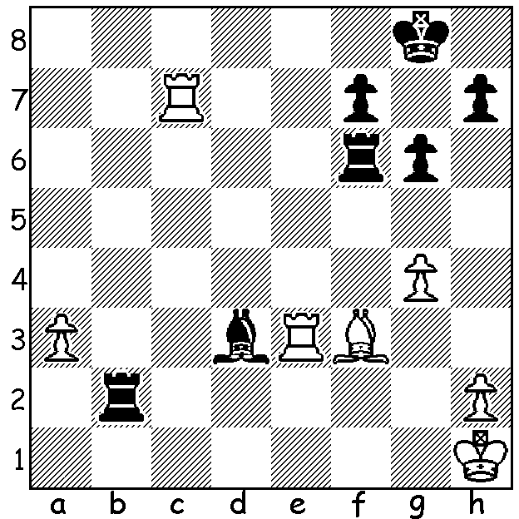

**Herman Pilnik vs**  *Spassky vs Fischer*

**Bobby Fischer 1959:** *World Championship 1972*

Black to play and win

(move 3 is tricky).

**2024 WORLD CHAMPIONSHIP**

FIDE (International Chess Federation) has called for bids for the **2024 World Championship** match between defending champion **Ding Liren** and winner of the recent Candidates tournament teenage sensation **Gukesh Dommaraju** which will be played between November 20th and December 15th. The big surprise is FIDE’s requirement of $8,500,000 to stage the match, which it claims is needed to help promote the game but it is way more than the last match which was between Magnus Carlsen and Ian Nepomiachtchi with a cost of under three million. Previously the most costly matches were (in today’s money equivalent) the Kasparov-Karpov match of 1990 with nearly six million and the Kasparov-Short match of 1993 with nearly five million. It was Bobby Fischer who can be credited with bringing in large amounts of money and making Chess a viable profession. His demands led his World Championship match with Boris Spassky in 1972 having prize money of $125,000 (5/8th to winner) plus a percentage of television and film rights. The amount equates to about one million today.

**CHESS ASSOCIATION NEWS**

The **WA Rapidplay Championship** was held on 28th April with 30 competitors. Winner was IM **Patrick Gong** with 6/6 with Ashvin Balavignan and Daniel Shen equal second with 5.5.

The **Bunbury Open** will be held on Saturday 18th and Sunday 19th (six rounds). For many years the Bunbury club hosted the very popular SW Open. The club has been resurrected and hopes players from Perth and the SW will support this event.

The **WA Championship** and **WA Reserves Championship** will be held from Friday 31st May to Monday 2nd June (7 rounds).

For details of these two events and entry see cawa.org.au

**SOLUTION**: 1…Rxf3! 2.Rxf3 Be4 3.Rxf7 Rf2! (Black now easily escapes checks and finishes a piece up).