CHESS 8 June 2024 David Ellis [ellisd19@bigpond.com](mailto:ellisd19@bigpond.com) 043979860

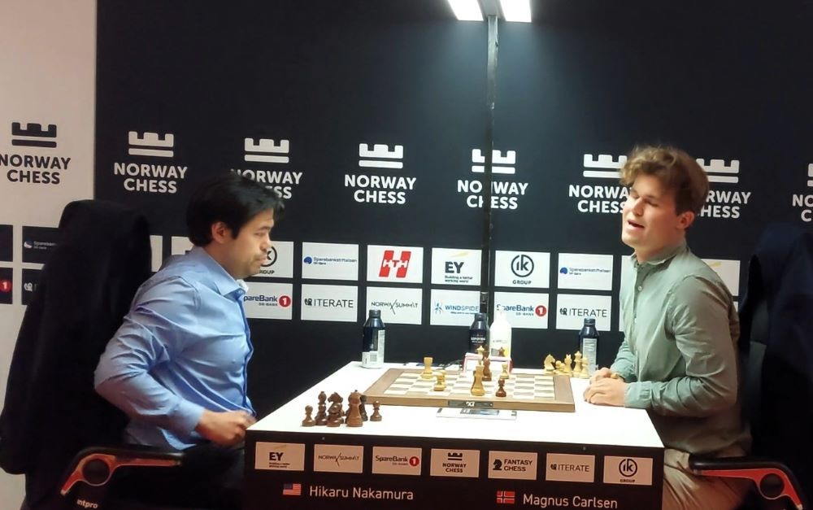 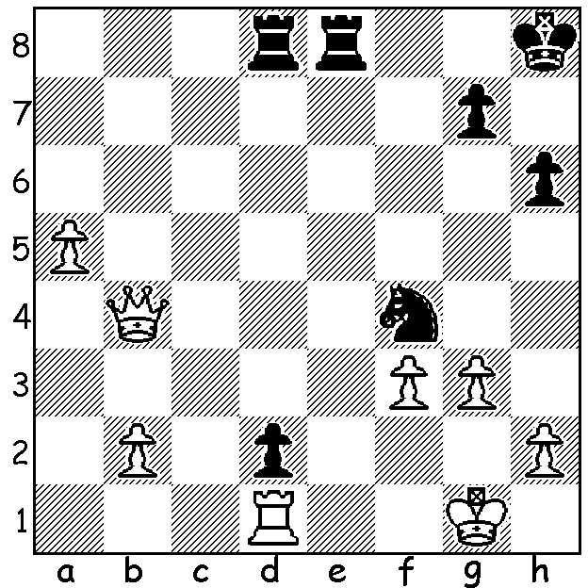

**Hikaru Nakamura vs Magnus Carlsen,** (Norway Chess 2024)

Black to play and reach virtual equality.

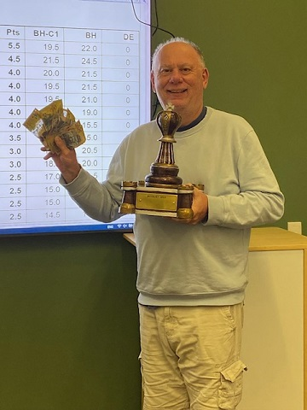 **BUNBURY OPEN**

For many years the S W Open was played in Bunbury

with the popular event attracting players and from all

over the South West as well as from Perth and this year

players were again able to enjoy a weekend of chess

there in the Bunbury Open held at Maneam Senior

College. Nineteen players competed in the six round

Swiss with former state champion Tim Hare finishing

on top with 5.5/6. Second was Boyd Mccamon (4.5)

and local player Michael Molenaar (4) third. Gary

Donaldson and Sid Bhosale (4) were the best Under

1700 players and Graeme Cotterill (4) the top Under

1350 player. After this successful inaugural event it

is hoped that next year many more players will be

attracted to compete*. (A happy winner, Tim Hare)*

**NORWAY 2024**

Six of the world’s top players, Magnus Carlsen, Fabiano Caruana, Hikaru Nakamura, world champion Ding Liren, Praggnanandhaa and Alireza Firouzja, have been competing in Norway Chess with its distinctive form of scoring. Players compete against each other in a double round robin. Games are played with Classic time controls (two hours on the clock with 10 second increments after move 40). However if the game is a draw an Armageddon game is played with same colours with White with 10 minutes needing to beat Black (7 min). Scoring: Classic - 3 points win, 1 point draw, Armageddon – White win half point. Black win or draw half point. The tournament has been played since 2113 with Carlsen winning on five occasions, Caruana in 2018 and Nakamura last year. This year there is also a similar event for top women players.

**SOLUTION**: White has queen and two pawns for rook and knight and after 1.Qb7-b4 (1.Kf1 is best) is attacking both knight and d pawn while defending against 1…Re1+. Despite Black having only 7 minutes for the whole game he finds 1…Rd4!! Now 2.Qc3? loses to 2…Ne2+ so 2.Qxd2 (2.Qxd4 loses a pawn to 2…Ne2+ 3.Kf2 Nxd4 3.Rxd2 Nb3 4.Rd5 Ra8) 2…Rxd2 3.Rxd2 with an ending with rook and five pawns against rook, knight and two pawns which Black may save and gain the Armageddon half point.