CHESS 22 June 2024 David Ellis [ellisd19@bigpond.com](mailto:ellisd19@bigpond.com) 043979860

 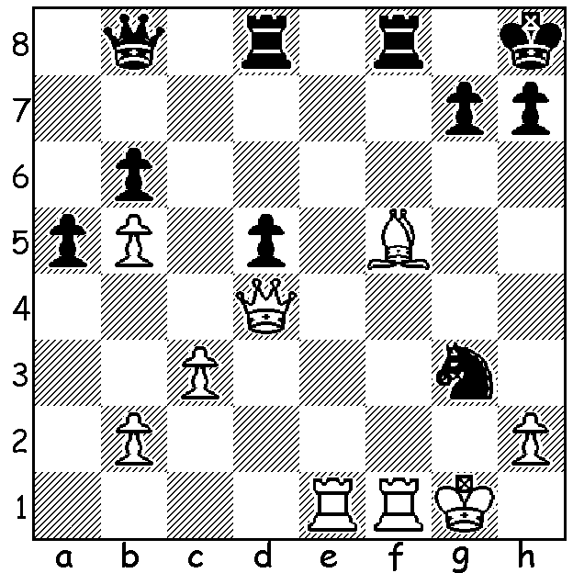

**Anna Muzychuk vs Lei Tingjie** (pictured):

Norway Chess 2024:

after Re7 Black has a brilliant win.

**NORWAY 2024 WOMEN**

**Norway Chess 2024**, besides having a six player tournament for top players, introduced a similar event for six leading female players with 10 rounds of Classic games with Armageddon games deciding winners in each round in the event of a draw (White 10min, Black 7min with White having to win). Classic win gains three points, Classic draw one point, win in Armageddon half point, draw by Black in Armegeddon half point. Winner was women’s world champion **Ju Wenjun** 19 pts (Classic +3 =7, Armageddon 6/7). Other scores: Anna Muzychuk 16 (+2 =8, 4/8), Lei Tingjie 14.5 (+2 =7 -1, 3/7) Vaishali Rameshbabu, sister of Pragg, 12.5 (+2 =5 -3, 3/5), Humpy Koneru 10 (+1 =6 -3, 2/5), Pia Cramling, 61 year-old veteran from Sweden, 8 (=7 -3, 2/7). Thirty three year old Ju Wenjun has won or defended her world title four times after first winning in 2018. She will defend the title next year against fellow Chinese Grandmaster Tan Zhongyi.

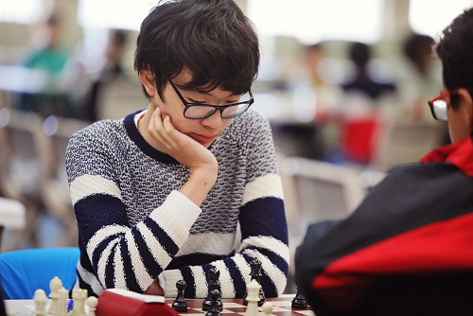**WA BLITZ CHAMPIONSHIP**

The **WA Blitz**, played at the State Library last

Sunday attracted 40 competitors. The top three

prize winners from the state championship also

took out the top three places in the Blitz with

junior **Rebo Fu** winning with 10/11, closely

followed by new WA champion **Daniel Shen** (9)

and three-times winner in both the WA

championship and the WA Blitz, **Patrick Gong** (8.5).

*Rebo Fu*

**SOLUTION**: Black has just played 1...Ne4xg3! (if 2.hxg3 Qxg3+ 3. Kh1 Rf6 wins). White’s counter 2.Re7, threatening mate, is met by 2…Rf7!! and after 3.Rxf7 (nothing better) 3…Ne2+ 4.Kg2 Nxd4 5.cxd4 the queen is too strong for the rook and bishop. Brilliant play in the Armageddon game!