CHESS 6 July 2024 David Ellis [ellisd19@bigpond.com](mailto:ellisd19@bigpond.com) 043979860

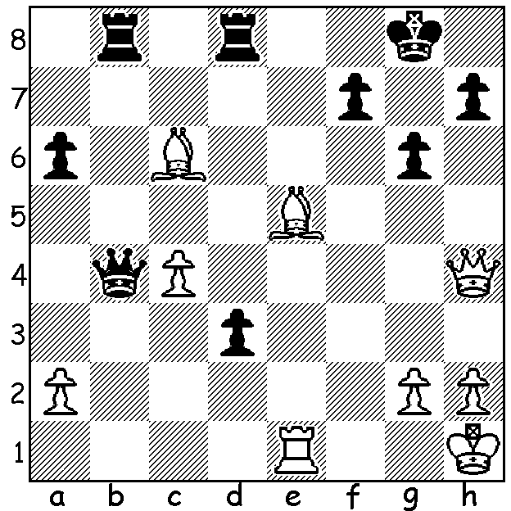

**Fabien Libiszewski vs Temur Kuybokarov** (pictured) **2017**

Black to play and win (move 3 is the clincher).

**AUSTRALIANS BOUND FOR HUNGARY**

For a number of years I have had the responsibility of being on the selection panel for the Australian Men’s Olympiad team with this year’s applicants all being very experienced in international events and all very deserving of selection. The final team chosen: Board 1. Australia’s leading player GM Temur Kuybokarov (WA, aged 23), who last year defeated Dommaraju Gukesh, this year’s challenger to Ding Liren for the world title: 2. GM Bobby Cheng (27), a former World Under 12 Champion; 3. IM Rishi Sardana, current Australian Champion (27); 4. GM Zhong-Yuan Zhao (37) who has played in three Olympiads; 5. GM David Smerdon (39), a veteran of six Olympiads who drew with then world champion Magnus Carlsen in the 2016 Olympiad; non-playing captain Jack Rogers who was also captain in Chennai 2022.

*Smerdon (L) and Carlsen analysing*

The Olympiad, the 45th, will be held 10-23 September in Budapest and will have around 200 nations in the world competing, making it one of the largest international sporting events of 2024. There are two sections, Open and Women’s with matches played over four boards. The previous Olympiad, held in Chennai, was won by Uzbekistan with Armenia second and India third. Australia finished =30th of 188 teams. (Next week the Australian women’s team.)

**ACF OLYMPIAD APPEAL**: a reminder that the Australian Chess Federation which receives no Government assistance, is seeking donations to assist our men and women with their travel to Budapest in September to compete in the 45th Chess Olympiad. Check out acfappeal.aunz.org

**SOLUTION**: the position highlights the passed pawn’s ‘lust to expand’ (Nimzovitsch) and the dangers of back row mates:1…Qxe1+!! 2.Qxe1 d2 3.Qd1 Rb1! 4.Qxb1 d1=Q+ 4.Qxd1 Rxd1# (if 4.Bf3 Rxd1 5.Bxd1 Re8 6.Bg3 Re1+).