CHESS 27 July 2024 David Ellis [ellisd19@bigpond.com](mailto:ellisd19@bigpond.com) 043979860



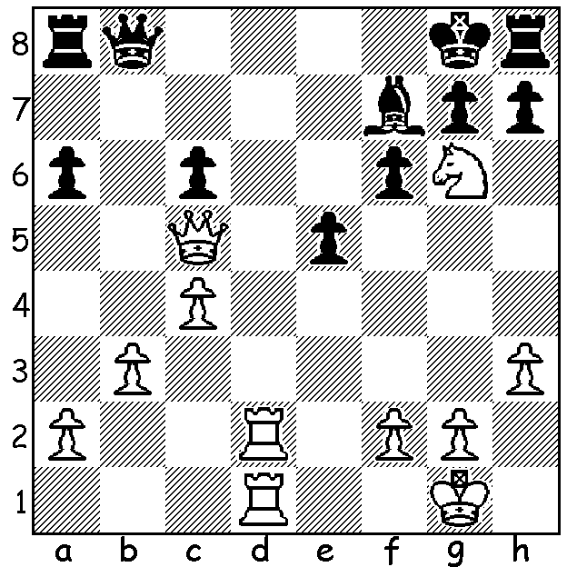

**David Smerdon vs**

**Svetoza Stojic 2001,**

White mates in 4.

**AUSTRALIAN GRANDMASTERS**

There are currently 10 Australian Grandmasters:

**Ian Rogers** GM 1985 aged 64, Australia’s highest rated player for over 20 years; represented Australia at 14 Olympiads; Australian Champion 4 times and winner of a number of international events; retired from competitive chess on medical advice in 2007 but remains active, principally in commentary and reporting.

**Darryl Johansen** GM 1995 aged 65, represented Australia at 14 Olympiads; Australian Champion 6 times (a record).

**Zong-Yuan Zhao**\* GM 2008 aged 38, represented Australia in 5 Olympiads, twice on Bd 1.

**David Smerdon**\* GM 2009 aged 39 represented Australia at 6 Olympiads; returned to chess last year after pursuing a career at University of Queensland.

**Max Illingworth** GM 2015 aged 31, represented Australia at 4 Olympiads; Australian Champion 2012 & 2018; semi-retired from competitive chess in 2019 to concentrate on coaching and writing.

**Moulthun Ly** GM 2016 aged 32; represented Australia in 2012 & 2014 Olympiads; first player born in Cambodia to become GM.

**Anton Smernov** GM 2018 aged 23, represented Australia in 4 Olympiads (unbeaten in 2014 & 2016 Olympiads).

**Justin Tan**\* GM 2018 aged 27, represented Australia at Olympiad 2022; former British Blitz Champion 2019.

**Temur Kuybokarov**\* GM 2019 moved from Uzbekistan to Perth in 2018; represented Australia at 2022 Olympiad; Australian Champion 2020 & 2022.

**Bobby Cheng**\* GM 2013 aged 26 represented Australia in 2018 Olympiad; only Australian to be an over-the board World Champion (Under 12 2009) Australian Champion 2016.

Sydney born **Walter Browne** GM 1970 (1949 – 2015); 1969 Australian Champion, US Champion 6 times; represented Australia in 1970 & 1972 Olympiads and USA 4 times.

(* Selected for forthcoming Olympiad in Budapest, September 10 to 23 September 2024)

**SOLUTION**: 1.Rd8+ Qxd8 2.Rxd8+ Rxd8 3.Qf8+!! Rxf8 4.Ne7#.