CHESS 03 August 2024 David Ellis [ellisd19@bigpond.com](mailto:ellisd19@bigpond.com) 043979860

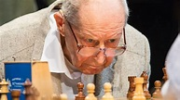 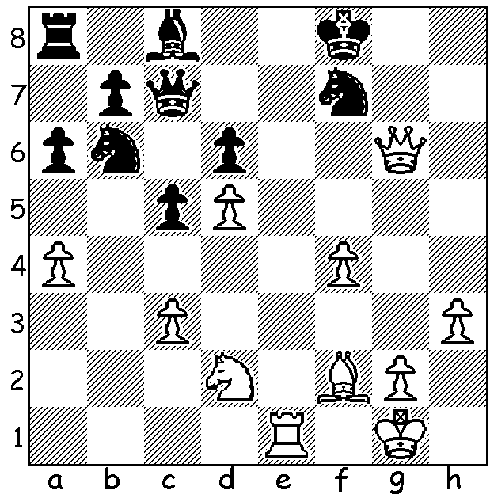

**Yuri Averbakh** (pictured) **vs Alexander Tolush 1953;** White mates quickly.

**ARE THERE TOO MANY GRANDMASTERS?**

I recently read an article suggesting the title was being devalued by the increasingly large number of Grandmasters. The term grandmaster had loosely been used to describe elite players from the nineteenth century but the title was first officially bestowed by Tsar Nicholas II on the five leading players from the 1914 St Petersburg Tournament, Emanuel Lasker, Jose Raul Capablanca, Alexander Alekhine, Frank Marshall and Akiba Rubinstein. FIDE, the international chess governing body, began awarding Grandmaster titles in 1950 with 27 players receiving the title. Over the years requirements have been formalised and today, from what I gather, a player must have a rating of 2500, gain three tournament achievement norms in tournaments of 9 players or more with at least 3 GMs from different countries participating, a time control of at least 120 mins and a tournament rating performance of at least 2600. Clearly the road to the title means dedicated years of study and tournament play with extended periods of travel. The number of GMs is now estimated to be around 2000 with the title for life. Nigel Short, vice-president of FIDE believes the title is now devalued, stating that in the 1970s there were only about 100 GMs. He doesn’t agree that a new title, Super Grandmaster, should be created for the elite players above 2700 and sees no solution saying, ‘It’s probably too late …. the horse has bolted’.

**OLDEST GRANDMASTER**

Russian GM **Yuri Averbakh** died on 7 May this year, three months after his 100th birthday, the first Chess centenarian. He was USSR champion in 1954 also came =1st in 1956 (2nd to Spassky after playoff). He was a highly regarded journalist and author and a major endgame theorist.

The **WILLETTON OPEN**; Canning Bridge Community, 63 Kishorn Rd., Mt Pleasant; Sat 17 & Sun 18 August, 3 rounds a day, 10.00am to 5.00+pm. See cawa.org.au

**SOLUTION**: 1.Re8+! (deflection) 1…Kxe8 2.Qg8+ Kd7 3.Qxf7+ Kd8 4.Bh4+ Qe7 5.Qxd7#; if 2.Ke7 3.Bh4+ Ng5 4.Bxg5+ Kd7 5.Qf7#.