CHESS 10 August 2024 David Ellis [ellisd19@bigpond.com](mailto:ellisd19@bigpond.com) 043979860

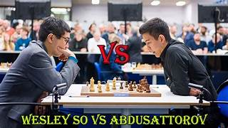 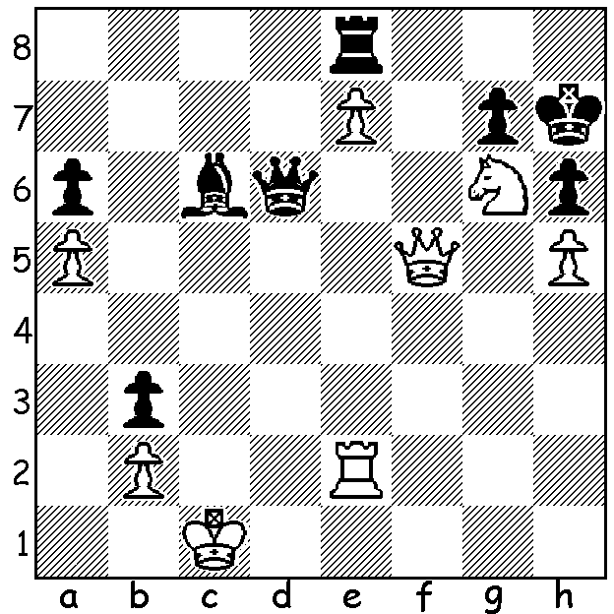

**Wesley So vs Nodirbok Abdusattorov** (Grand Chess Tour Romania 2024)

Black to play has an unusual draw.

**ANOTHER FAB VICTORY**

After winning the Grand Chess Tour Classic in Bucharest, Romania, **Fabiano Caruana** followed this up with victory in the Grand Chess Tour Rapid and Blitz played in Zagreb, Croatia (9 rounds Rapid with 2pts for win, 18 rounds Blitz with 1pt for win). An outstanding result, Fabiano won the tournament with five rounds to spare and equalled Magnus Carlsen’s winning score of 27/36. well ahead of Wesley So, Maxime Vachier-Lagrave and Alireza Firouzja on 23, followed by Ian Nepomniachtchi 13.5, Levon Aronian 11.5, Anish Giri 10.5, Gukesh 9.5, Ivan Saric 8.5. Carlsen had been scheduled to play but withdrew for family reasons. Caruana now leads the Tour with 22.5, ahead of Firouzja with 17.5.

**WORLD SENIORS**

The World Seniors Team Championships, played in Krakow in Poland, attracted 65 teams and 307 players, 32 of whom were GMs. **USA** won the 50+ event with 16/18 match points (+8, -1), followed by Italy 15 (+7, =1, -1) and England 14 (+6, =1, -1). **England** won the +65 with 16 (+7, =2), followed by Israel 15 (+7, =1, -1) and France 14 (+6, =2 -1). The English teams were headed by Michael Adams and John Nunn, the reigning +50 & +65 world champions, who both won individual top board gold.

The **WILLETTON OPEN**; Canning Bridge Community, 63 Kishorn Rd., Mt Pleasant; Sat 17 & Sun 18 August, 3 rounds a day, 10.00am to 5.00+pm. See cawa.org.au

**SOLUTION**: 1…Be4!! 2.Rxe4 (if 2.Qxe4? Rc8+ mates) 2…Rc8+!! 3.Qxc8 Qd1+!! 4.Kxd1 stalemate. Not surprisingly this combination was only ‘seen’ by a chess engine with Black playing 1…Bb5. The game continued with both kings being driven around the board before Black took a draw by perpetual check.